|  |
| --- |
|  |
| Capstone Project Document |

**DANDELION**

Report #2 – Class Design

|  |  |  |
| --- | --- | --- |
| **Dandelion** | | |
| **Group Members** | Vũ Công Chính | SE02585 |
| Lưu Ngọc Mạnh | SE02619 |
| Nguyễn Minh Huy | SE02723 |
| Dương Đức Anh | SE02700 |
| Vũ Ngọc Trung | SE02967 |
| Cao Thị Phương Mai | SE02908 |
| **Supervisor** | Mr. Nguyễn Văn Sang | |
| **Project code** | DDL | |

**- Hanoi, 09/2015 -**

# SIGNATURE PAGE

AUTHOR: Lưu Ngọc Mạnh 28/09/2015

Project Manager

REVIEWERS: Nguyễn Minh Huy 30/09/2015

Team member

APPROVAL: Nguyễn Văn Sang --/--/--15

Supervisor

Record of change

*A - Added M - Modified D – Deleted

|  |  |  |  |  |  |
| --- | --- | --- | --- | --- | --- |
| Effective Date | Changed Item | A,M,D | Change Description | Reason for Change | Rev. Number |
| 28/Sep/2015 | Create Class Design | A | First version | Create Class Design | 1.0 |
|  |  |  |  |  |  |
|  |  |  |  |  |  |
|  |  |  |  |  |  |
|  |  |  |  |  |  |
|  |  |  |  |  |  |
|  |  |  |  |  |  |
|  |  |  |  |  |  |
|  |  |  |  |  |  |
|  |  |  |  |  |  |
|  |  |  |  |  |  |
|  |  |  |  |  |  |
|  |  |  |  |  |  |
|  |  |  |  |  |  |
|  |  |  |  |  |  |
|  |  |  |  |  |  |
|  |  |  |  |  |  |
|  |  |  |  |  |  |
|  |  |  |  |  |  |
|  |  |  |  |  |  |
|  |  |  |  |  |  |
|  |  |  |  |  |  |
|  |  |  |  |  |  |
|  |  |  |  |  |  |

TABLE CONTENTS

SIGNATURE PAGE 1

1 Introduction 4

1.1 Purpose 4

1.2 Definitions, Acronyms and Abbreviations 4

2 Package 4

2.1 Package Diagram 4

2.2 Package Description 5

2.2.1 Model 5

2.2.2 DTOs 12

2.2.3 View 12

2.2.4 Controller 13

3 Function 24

3.1 Common 24

3.1.1 Class diagram 24

3.1.2 Sequence diagram 24

3.2 Project 27

3.2.1 Class diagram 27

3.2.2 Sequence diagram 27

3.3 Comment 38

3.3.1 Class diagram 38

3.3.2 Sequence diagram 38

3.4 Message 40

3.4.1 Class diagram 40

3.4.2 Sequence diagram 41

3.5 User 42

3.5.1 Class diagram 42

3.5.2 Sequence diagram 42

3.6 Report 44

3.6.1 Class diagram 44

3.6.2 Sequence diagram 44

3.7 Manage Slide 44

3.7.1 Class diagram 44

3.7.2 Sequence diagram 45

3.8 Manage Category 48

3.8.1 Class diagram 48

3.8.2 Sequence diagram 49

# Introduction

## Purpose

Dandelion class design document contains descriptions of all classes of the Dandelion. It includes: Class diagrams that describe the static relation of all classes in the system.

## Definitions, Acronyms and Abbreviations

|  |  |  |
| --- | --- | --- |
| Abbreviations | Description | Comment |
| DDL | Dandelion |  |
| FAQ | Frequently Asked Question |  |

1. Definitions, Acronyms and Abbreviations

# Package

## Package Diagram

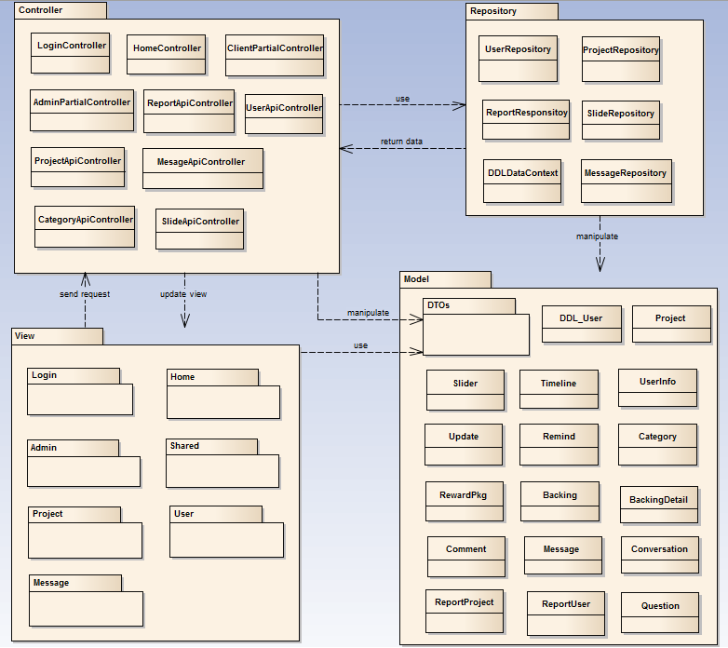

1. Package Diagram

## Package Description

### Model

#### DDL_User

|  |  |  |  |  |  |
| --- | --- | --- | --- | --- | --- |
| **No** | **Field Name** | **Type** | **Default** | **Note** | **Description** |
|  | UserID | int |  | private | User’s ID |
|  | UserName | String |  | private | User’s name |
|  | Password | String |  | private | User’s password |
|  | IsActive | bool | false | private | User’s active status (inactive, active) |
|  | CreatedDate | Datetime |  | private | User’s created date |
|  | LoginType | String | normal | private | User’s created type includes: normal, Facebook or both |
|  | LastLogin | Datetime |  | private | User’s last login |
|  | UserType | String | normal | private | User’s type (admin or nomal user) |
|  | IsVerify | bool | false | private | User’ email verify status |

1. DDL_User model

#### Userinfo

|  |  |  |  |  |  |
| --- | --- | --- | --- | --- | --- |
| **No** | **Field Name** | **Type** | **Default** | **Note** | **Description** |
|  | UserID | int |  | private | Person’s ID |
|  | FullName | String |  | private | Person’s full name |
|  | ProfileImage | String |  | private | Person’s profile image |
|  | Biography | String |  | private | Person’s biography |
|  | Address | String |  | private | Person’s address |
|  | Gender | String | male | private | Person’s gender |
|  | PhoneNumber | String |  | private | Person’s phone number |
|  | DateOfBirth | Datetime |  | private | Person’s date of birth |
|  | Website | String |  | private | Person’s website |
|  | FacebookURL | String |  | private | Person’s facebook link |

1. UserInfo model

#### Project

|  |  |  |  |  |  |
| --- | --- | --- | --- | --- | --- |
| **No** | **Field Name** | **Type** | **Default** | **Note** | **Description** |
|  | ProjectID | int |  | private | Project’s ID |
|  | ProjectCode | String |  | private | Project’s code with fixed format |
|  | CategoryID | int |  | private | Project’s category |
|  | CreatorID | int |  | private | Project’s UserID who created project |
|  | ProjectTitle | String |  | private | Project’s title |
|  | Risk | String |  | private | Project’s risk |
|  | ImageURL | String |  | private | Project’s image link |
|  | SubDescription | String |  | private | Project’s sub description |
|  | Location | String |  | private | Project’s location created |
|  | IsExpired | bool |  | private | Is Project’s expired |
|  | CurrentFunded | demical |  | private | Project’s funded status |
|  | IsFunded | bool |  | private | Is Project’s funded |
|  | CreatedDate | datetime |  | private | Project’s createdDate |
|  | ExpiredDate | datetime |  | private | Project’s expired date |
|  | FundingGoal | decimal |  | private | Project’s funding goal |
|  | Description | String |  | private | Project’s description |
|  | LinkVideo | String |  | private | Project’s video link |
|  | Story | String |  | private | Project’s story |
|  | PopularPoint | int | 0 | private | Project’s popular point |
|  | Status | String | draft | private | Project’s status ( draft, pending, approved, suspended) |

1. Project model

#### Question Model

|  |  |  |  |  |  |
| --- | --- | --- | --- | --- | --- |
| **No** | **Field Name** | **Type** | **Default** | **Note** | **Description** |
|  | QuestionID | Int |  | private | question’s ID |
|  | ProjectID | Int |  | private | question’s project id |
|  | Question | String |  | private | question’s question |
|  | Answer | String |  | private | question’s answer |
|  | CreatedDate | Datetime |  | private | question’s created date |

1. Question Model

#### Category model

|  |  |  |  |  |  |
| --- | --- | --- | --- | --- | --- |
| **No** | **Field Name** | **Type** | **Default** | **Note** | **Description** |
|  | CategoryID | int |  | private | Category’s ID |
|  | Name | String |  | private | Category’s name |
|  | IsActive | bool | false | private | Category’s active status |
|  | Description | String |  | private | Category’s description |

1. Category Model

#### UpdateLog Model

|  |  |  |  |  |  |
| --- | --- | --- | --- | --- | --- |
| **No** | **Field Name** | **Type** | **Default** | **Note** | **Description** |
|  | UpdateID | int |  | private | Update’s ID |
|  | ProjectID | Int |  | private | Update’s project id |
|  | Title | String |  | private | Update’s title |
|  | Description | String |  | private | Update’s description |
|  | CreatedDate | datetime |  | private | Update’s created date |

1. Update Model

#### Timeline Model

|  |  |  |  |  |  |
| --- | --- | --- | --- | --- | --- |
| **No** | **Field Name** | **Type** | **Default** | **Note** | **Description** |
|  | TimelineID | int |  | public | Timeline’s ID |
|  | ProjectID | int |  | public | Timeline’s project id |
|  | Title | String |  | public | Timeline’s title |
|  | Description | String |  | public | Timeline’s description |
|  | DueDate | datetime |  | public | Timeline’s due date |

1. Timeline Model

#### ReportProject Model

|  |  |  |  |  |  |
| --- | --- | --- | --- | --- | --- |
| **No** | **Field Name** | **Type** | **Default** | **Note** | **Description** |
|  | ReportID | int |  | private | Report ’s ID |
|  | ProjectID | int |  | private | Report ’s project id |
|  | UserID | int |  | private | Report ’s user id, who report project |
|  | Subject | String |  | private | Report ’s subject |
|  | ReportContent | String |  | private | Report ’s content |
|  | ReportDate | datetime |  | private | Report ’s report date |
|  | Status | String | new | private | Report’s status (new, viewed, done) |

1. ReportProject Model

#### Remind Model

|  |  |  |  |  |  |
| --- | --- | --- | --- | --- | --- |
| **No** | **Field Name** | **Type** | **Default** | **Note** | **Description** |
|  | RemindID | int |  | private | Remind’s ID |
|  | ProjectID | int |  | private | Remind’s project id |
|  | UserID | int |  | private | Remind’s user id |

1. Remind Model

#### Backing Model

|  |  |  |  |  |  |
| --- | --- | --- | --- | --- | --- |
| **No** | **Field Name** | **Type** | **Default** | **Note** | **Description** |
|  | BackingID | int |  | private | Back’s ID |
|  | UserID | int |  | private | Back’s user id |
|  | ProjectID | int |  | private | Back’s project id |
|  | BackedDate | Datetime |  | private | Back’s date |
|  | Description | String |  | private | Back’s description |
|  | IsPublic | bool | true | private | Is back public |

1. Backing Model

#### BackingDetail Model

|  |  |  |  |  |  |
| --- | --- | --- | --- | --- | --- |
| **No** | **Field Name** | **Type** | **Default** | **Note** | **Description** |
|  | BackingID | int |  | private | Backing’s ID |
|  | BackerName | string |  | private | Name of backer |
|  | RewardPkgID | int |  | private | Identify number of reward package |
|  | PledgedAmount | decimal | 0 | private | total pledged amount |
|  | Quantity | int | 1 | private | quantity of reward |
|  | Description | string |  | private | Backing’s description |
|  | Address | string |  | private | Backer’s address |
|  | PhoneNumber | string |  | private | Backer’s phone number |
|  | Email | string |  | private | Backer’s email |

1. BackingDetail Model

#### Comment Model

|  |  |  |  |  |  |
| --- | --- | --- | --- | --- | --- |
| **No** | **Field Name** | **Type** | **Default** | **Note** | **Description** |
|  | CmtID | int |  | private | Comment’s ID |
|  | UserID | int |  | private | Comment’s user id |
|  | ProjectID | int |  | private | Comment’s project id |
|  | CmtContent | String |  | private | Comment’s content |
|  | CmtDate | Datetime |  | private | Comment’s date |
|  | IsHide | bool | false | private | Is Comment’s hide |
|  | UpdatedDate | Datetime |  | private | Comment;’s updated datetime |
|  | IsEdited | bool | false | private | Is comment edited |

1. Comment Model

#### ReportUser Model

|  |  |  |  |  |  |
| --- | --- | --- | --- | --- | --- |
| **No** | **Field Name** | **Type** | **Default** | **Note** | **Description** |
|  | ReportID | int |  | private | Report’s ID |
|  | ReportUserID | int |  | private | Report’s report user ID |
|  | ReportedUserID | int |  | private | Report’s reported user ID |
|  | Status | String |  | private | Report’s status (new, viewed, done) |
|  | Subject | String |  | private | Report’s Subject |
|  | ReportContent | String |  | private | Report’s content |
|  | ReportDate | datetime |  | private | Report’s date |

1. ReportUser Model

#### Slide Model

|  |  |  |  |  |  |
| --- | --- | --- | --- | --- | --- |
| **No** | **Field Name** | **Type** | **Default** | **Note** | **Description** |
|  | SlideID | int |  | private | Slide’s ID |
|  | SlideTitle | String |  | private | Slide’s title |
|  | Order | int |  | private | Slide’s order |
|  | Description | String |  | private | Slide’s description |
|  | ImageLink | String |  | private | Slide’s image link |
|  | VideoUrl | String |  | private | Slide’s video |
|  | IsActive | bool | false | private | Slide’s isActive status |
|  | SliderURL | String |  | private | Slide’s slide URL |
|  | ButtonColor | String | green | private | Slide’s button color |
|  | CreatedDate | datetime |  | private | Slide’s created date |
|  | TextColor | string | light | private | slide’s text color |
|  | ButtonText | String |  | private | Slide’s button text |

1. Slide Model

#### Conversation Model

|  |  |  |  |  |  |
| --- | --- | --- | --- | --- | --- |
| **No** | **Field Name** | **Type** | **Default** | **Note** | **Description** |
|  | ConversationID | int |  | private | Conversation’s ID |
|  | CreatorID | int |  | private | Conversation’s creator id |
|  | ReceiverID | int |  | private | Conversation’s receiver |
|  | Subject | String |  | private | Conversation’s subject |
|  | CreatedDate | Datetime |  | private | Conversation’s created date |
|  | UpdatedDate | Datetime |  | private | Conversation’s update date |
|  | DeleteStatus | String | no | private | Conversation’s user delete status |
|  | ViewStatus | String | creator | private | Conversation’s user view status |

1. Conversation Model

#### Message Model

|  |  |  |  |  |  |
| --- | --- | --- | --- | --- | --- |
| **No** | **Field Name** | **Type** | **Default** | **Note** | **Description** |
|  | MessageID | int |  | private | Message’s ID |
|  | ConversationID | int |  | private | Message’s conversation id |
|  | UserID | int |  | private | Message’s user id |
|  | MessageContent | String |  | private | Message’s content |
|  | SentTime | Datetime |  | private | Message’s sent time |

1. Message Model

#### RewardPkg Model

|  |  |  |  |  |  |
| --- | --- | --- | --- | --- | --- |
| **No** | **Field Name** | **Type** | **Default** | **Note** | **Description** |
|  | RewardID | int |  | private | Reward’s ID |
|  | ProjectID | int |  | private | Reward’s project id |
|  | LimitedQuantity | int |  | private | Reward’s limited quantity |
|  | Type | String |  | private | Reward’s type (noReward, limited, unlimited) |
|  | Description | String |  | private | Reward’s description |
|  | EstimatedDeliveryDate | datetime |  | public | Reward’s estimated delivery date |
|  | IsHide | bool | true | public | Is Reward hide |

1. Reward package table

### DTOs

|  |  |  |
| --- | --- | --- |
| **No** | **Class Name** | **Description** |
|  | AdminBackingListDTO | Object to transfer backing list data |
|  | AdminBakingFullInforDTO | Object to transfer backing list data for export |
|  | AdminCategoryDTO | Object to transfer category data |
|  | AdminDashboardInfoDTO | Object to transfer information data for admin dashboard |
|  | AdminProjectGeneralInfoDTO | Object to transfer project dashboard information data |
|  | AdminProjectStatisticDTO | Object to transfer project statistic data |
|  | AdminUserBackedListDTO | Object to transfer baking list data of a user |
|  | AdminUserBackingDetailDTO | Object to transfer backing detail data |
|  | AdminUserCreatedListDTO | Object to transfer list created project data of a user. |
|  | AdminUserDashboardDTO | Object to transfer user dashboard information data |
|  | AdminUserListDTO | Object to transfer data of list user for admin page. |
|  | AdminUserProfileDTO | Object to transfer profile information data of a user |
|  | BackingDTO | Object to transfer backing data |
|  | BackingInfoDTO | Object to transfer backing information data |
|  | CategoryDTO | Object to transfer category data |
|  | CategoryProjectCountDTO | Object to transfer category with project count data |
|  | CommentDTO | Object to transfer comment data |
|  | ConversationBasicDTO | Object to transfer conversation basic data |
|  | ConversationDetailDTO | Object to transfer detail data of a conversation |
|  | EditPasswordDTO | Object to transfer password data for change password functions |
|  | HttpMessageDTO | Object to transfer data for Web Api |
|  | MessageDTO | Object to transfer message data |
|  | NewMessageDTO | Object to transfer new message data |
|  | NewMessageNumberDTO | Object to transfer data number of new message |
|  | ProjectBackDTO | Object to transfer backing data of project |
|  | ProjectBasicListDTO | Object to transfer list basic information of projects |
|  | ProjectBasicViewDTO | Object to transfer basic information of a project |
|  | ProjectCreateDTO | Object to transfer project information for create project page |
|  | ProjectDetailDTO | Object to transfer detail data of a project |
|  | ProjectEditDTO | Object to transfer edited data of a project |
|  | ProjectInfoBackDTO | Object to transfer backing information data |
|  | ProjectStoryDTO | Object to transfer story information data of a project |
|  | QuestionDTO | Object to transfer question & answer data |
|  | ReplyDTO | Object to transfer reply message data |
|  | ReportProjectDTO | Object to transfer report project data |
|  | ReportUserDTO | Object to transfer report user data |
|  | RewardPkgDTO | Object to transfer reward package data |
|  | SlideDTO | Object to transfer slide data |
|  | UpdateLogDTO | Object to transfer update log data |
|  | UserBackInforDTO | Object to transfer backing information data of a user |
|  | UserEditInfoDTO | Object to transfer edited profile information data of a user |
|  | UserLoginDTO | Object to transfer login data |
|  | UserNameDTO | Object to transfer username and full name data of user |
|  | UserPublicInfoDTO | Object to transfer public information data of a user |
|  | UserRegisterDTO | Object to transfer registered information data |

### View

Contain many .cshtml files to display user interface.

### Repository

#### UserRepository

|  |  |  |  |  |
| --- | --- | --- | --- | --- |
| No | Method | Parameter | Return | Description |
|  | GetBackingFullInforListForExport |  | List<Object> | Get backing list for export |
|  | GetUserTop | string | Dictionary<Object> | Get top 10 user |
|  | GenerateNewPassword |  | string | Generate new password from random string |
|  | GenerateResetCode |  | string | Generate reset password code from random string |
|  | GenerateRandomString | int | string | Generate random string |
|  | GetByUserNameOrEmail | string, string | DDL_User | Get user by username, email and password |
|  | GetByUserNameOrEmail | string | DDL_User | Get user by username or email |
|  | GetBasicInfo | string | UserBasicInfoDTO | get basic information of a user |
|  | InsertUser | DDL_User | DDL_User | Insert user into DB |
|  | RegisterFacebook | dynamic | DDL_User | register new user from facebook information |
|  | Register | UserRegisterDTO | DDL_User | Register new user by normal way |
|  | VerifyAccount | string, string |  | Verify account by code |
|  | UpdateUser | DDL_User | DDL_User | Update information of a user |
|  | SendCodeResetPassword | string | bool | Update reset code into DB |
|  | ResetPassword | string, string | bool | Reset password of a user |
|  | GetListUserName | string | List<UserNameDTO> | Get all username of user in system. |
|  | GetUserPublicInfo | string | UserPublicInfoDTO | Get public information of a user. |
|  | GetUserEditInfo | string | UserEditInfoDTO | Get information of a user to display in edit profile page. |
|  | EditUserInfo | UserEditInfoDTO,  string |  | Edit profile of a user. |
|  | GetUserPassword | string | EditPasswordDTO | Get password of a user. |
|  | ChangePassword | string,  EditPasswordDTO | bool | Change password of a user. |
|  | GetUserListForAdmin |  | AdminUserListDTO | Get list user for admin page. |
|  | ChangeUserStatus | string |  | Active or deactive a user |
|  | GetUserDashboardForAdmin |  | AdminUserDashboardDTO | Get user dash board for admin page. |
|  | AdminGetTopBacker |  | List<TopBackerDTO> | Get top 10 backer of dandelion. |
|  | AdminGetRecentUser |  | List<RecentUserDTO> | Get last login user. |

1. User Repository

#### ProjectRepository

|  |  |  |  |  |
| --- | --- | --- | --- | --- |
| No | Method | Parameter | Return | Description |
|  | GetStatisticsInfor |  | Dictionary<string, int> | Get statistic information |
|  | GetProjectTop | string | List<ProjectBasicViewDTO> | Get list top 10 project |
|  | SearchCount | string,  string | int |  |
|  | GetProject | int, int, string, string, string, string bool, string | List<ProjectBasicViewDTO> | Get project by options |
|  | orderBy | string,  IQueryable<ProjectBasicViewDTO> | IQueryable<ProjectBasicViewDTO> | Order list of project by options |
|  | GetProjectByCategory |  | List<ProjectBasicViewDTO> | get project by category |
|  | GetTotalFund |  | List<ProjectBasicViewDTO> | Get total funded of system |
|  | CreatProject | ProjectCreateDTO,  string | string | Create a draft project |
|  | EditProjectBasic | ProjectEditDTO, string | ProjectEditDTO | edit basic information of a project |
|  | EditProjectStory | ProjectStoryDTO | ProjectStoryDTO | edit advanced information of a project |
|  | GetProjectBasic | string, string | ProjectEditDTO | Get basic information of a project |
|  | GetProjectStory | int | ProjectStoryDTO | Get advanced information of a project |
|  | SubmitProject | ProjectEditDTO | List<string> | Submit a project for review |
|  | GetBackProjectInfo | string | ProjectInfoBackDTO | Get baking information of a project |
|  | BackProject | ProjectBackDTO | string | Back project |
|  | CaculateProjectPoint | string,  int |  | Calculate project point |
|  | AdminGetBackingDetail | int | ProjectBackDTO | Get detail information of a backing |
|  | AdminProjectGeneralInfo | AdminProjectGeneralInfoDTO |  | Get project dashboard information |
|  | GetPendingProjectList | List<ProjectBasicListDTO> |  | Get list pending project |
|  | GetProjectList | List<ProjectBasicListDTO> |  | Get project list |
|  | AdminChangeProjectStatus | ProjectEditDTO,  string | bool | Approve/ Reject a project |
|  | AdminDashboardInfo |  | AdminDashboardInfoDTO | Get dashboard information |
|  | AdminGetTopProjectList |  | List<ProjectBasicListDTO> | Get top 10 project |
|  | AdminProjectStatistic | int | AdminProjectStatisticDTO | Get project statistic information |
|  | AdminStatisticTable | string | List<AdminDashboardInfoDTO> | Get project statistic information |
|  | AdminGetProjectDetail | string | ProjectDetailDTO | Get project detail information |
|  | GetProjectByCode | string,  string | ProjectDetailDTO | Get project detail information by code. |
|  | GetListComment | string,  datetime,  string | List<CommentDTO> | Get list comment of a project |
|  | GetListUpdateLog | string, string | List<UpdateLogDTO> | Get list update log of a project |
|  | GetBackedProjectHistory | string | List<ProjectBasicViewDTO> | Get backed project history information |
|  | BackingInfo | string | List<BackingInfoDTO> | Get backing information |
|  | GetBackedProject | string | List<ProjectBasicViewDTO> | Get list backed project |
|  | GetStarredProject | string | List<ProjectBasicViewDTO> | Get list reminded project |
|  | GetCreatedProject | string | List<ProjectBasicViewDTO> | Get list created project |
|  | DeleteProjectReminded | int | bool | Delete remind from a project |
|  | DeleteProjectDraft | int | bool | delete a draft project |
|  | RemindProject | string, string | bool | remind a project |
|  | GetListBacker | string | BackingDTO | Get list backing of a project |
|  | GetComments | int, bool, datetime | List<CommentDTO> | Get list comment of a project |
|  | AddComment | string, CommentDTO, datetime | List<CommentDTO> | Add a comment |
|  | ShowHideComment | int, string | CommentDTO | Show hide comment for creator |
|  | EditComment | int, string, string | CommentDTO | Edit a comment |
|  | DeleteComment | int, string | bool | Delete a comment |

1. Project Repository

#### ReportRepository

|  |  |  |  |  |
| --- | --- | --- | --- | --- |
| No | Method | Parameter | Return | Description |
|  | ReportProject | string, string, string |  | Use to request login to Facebook |
|  | ReportUser | string, string, string |  | Function callback, get data from Facebook |
|  | GetReportProjects |  | List<ReportProjectDTO> | Set user’s password to a random string and send to email of user |
|  | GetReportUsers |  | List<ReportUserDTO> |  |
|  | changeReportProjectStatus | int¸ string |  |  |
|  | changeReportUserStatus | int, string |  |  |

1. Report Repository

#### MessageRepository

|  |  |  |  |  |
| --- | --- | --- | --- | --- |
| No | Method | Parameter | Return | Description |
|  | GetListConversation | string | List<ConversationBasicDTO> | List list converstion of a user. |
|  | GetListSentConversation | string | List<ConversationBasicDTO> | Get list sent conversation of a user. |
|  | GetListReceivedConversation | string | List<ConversationBasicDTO> | Get list receiver conversation of a user |
|  | GetConveration | int, string | ConversationDetailDTO | Get conversation detail |
|  | ReplyMessage | ReplyDTO,  string | MessageDTO | Reply a conversation |
|  | Delete | int, string | bool | Delete a conversation |
|  | DeleteMessageList | int[], string | bool | Delete a list conversation |

1. Message Repository

#### SlideRepository

|  |  |  |  |  |
| --- | --- | --- | --- | --- |
| No | Method | Parameter | Return | Description |
|  | GetSlides |  | List<SlideDTO> | Get list slide. |
|  | CreateSlide | SlideDTO | SlideDTO | create new slide |
|  | EditSlide | SlideDTO | SlideDTO | edit a slide |
|  | DeleteSlide | int | bool | delete a slide |
|  | ChangeSlideStatus | int | SlideDTO | active or deactive a slide |
|  | ChangeOrder | int, string | List<SlideDTO> | chang slide’s order |

1. Slide Repository

#### CategoryRepository

|  |  |  |  |  |
| --- | --- | --- | --- | --- |
| No | Method | Parameter | Return | Description |
|  | GetCategoryProjectCount |  | List<CategoryProjectCountDTO> | Get list category with project count |
|  | GetCategoryProjectStatistic |  | List<CategoryProjectCountDTO> | get list categories for statistic page |
|  | GetAllCategories |  | List<CategoryProjectCountDTO> | get all categories |
|  | GetCategoriesForAdmin |  | List<AdminCategoryDTO> | Get litst categories for admin page |
|  | GetCategories |  | List<CategoryDTO> | Get list categories |
|  | ChangeCategoryStatus | int | AdminCategoryDTO | Active/deactive category |
|  | AddNewCategory | AdminCategoryDTO | AdminCategoryDTO | add new category |
|  | EditCategory | AdminCategoryDTO | AdminCategoryDTO | edit a category |

1. Category Repository

### Controller

#### LoginController

|  |  |  |  |  |
| --- | --- | --- | --- | --- |
| No | Method | Parameter | Return | Description |
|  | AuthenFacebook |  | ActionResult | Use to request login to Facebook |
|  | FacebookCallback | string | ActionResult | Function callback, get data from Facebook |
|  | ForgotPassword |  | ActionResult | Set user’s password to a random string and send to email of user |
|  | Login | string | ActionResult | Return login page for user |
|  | Login | UserLoginDTO,  string | ActionResult | Receive request login with form data included user name and password. |
|  | Logout |  | ActionResult | Logout current user from DDL. |
|  | AdminLogin | string |  | Return login page for admin. |
|  | AdminLogin | UserLoginDTO, string | ActionResult | Receive request login with form data included user name and password. |
|  | AdminLogout |  | ActionResult | Logout for admin page. |
|  | Active | string, string | ActionResult | Verify email account, active new account with code. |

1. Login Controller

#### HomeController

|  |  |  |  |  |
| --- | --- | --- | --- | --- |
| No | Method | Parameter | Return | Description |
|  | Index |  | ActionResult | Display main page of DDL client. |
|  | AdminIndex |  | ActionResult | Display main page of DDL admin. |
|  | Error |  | ActionResult | Display error page |

1. Home Controller

#### ClientPartialController

|  |  |  |  |  |
| --- | --- | --- | --- | --- |
| No | Method | Parameter | Return | Description |
|  | Home |  | ActionResult | Display home page |
|  | Register |  | ActionResult | Display Register page |
|  | RegisterSuccess |  | ActionResult | Display register successful page |
|  | ForgotPassword |  | ActionResult | Display ForgotPassword page |
|  | Discover |  | ActionResult | Display discovery page |
|  | Message |  | ActionResult | Display message list page |
|  | MessageDetail |  | ActionResult | Display message detail page |
|  | CreateProject |  | ActionResult | Display create project page |
|  | ProjectDetail |  | ActionResult | Display project detail page |
|  | EditProject |  | ActionResult | Display Edit Project page |
|  | Statistics |  | ActionResult | Display Statistics page |
|  | Search |  | ActionResult | Display Search result page page |
|  | BackProject |  | ActionResult | Display first Backing page with list rewards of project. |
|  | PaymentProject |  | ActionResult | Display second Backing page to input backing information. |
|  | PublicProfile |  | ActionResult | Display Public Profile page |
|  | EditProfile |  | ActionResult | Display Edit Profile page |
|  | EditPassword |  | ActionResult | Display Edit Password page |
|  | Message |  | ActionResult | Display Message page |
|  | BackedProject |  | ActionResult | Display Backed Project page |
|  | BackedProjectHistory |  | ActionResult | Display backed history page |
|  | CreatedProject |  | ActionResult | Display Created Project page |
|  | StarredProject |  | ActionResult | Display Reminded Project page |
|  | ListBacker |  | ActionResult | Display page with list backing of a project. |
|  | Error |  | ActionResult | Display Error page. |
|  | NotFound |  | ActionResult | Display 404 not found page. |

1. ClientPartialController

#### AdminPartialController

|  |  |  |  |  |
| --- | --- | --- | --- | --- |
| No | Method | Parameter | Return | Description |
|  | Dashboard |  | ActionResult | Display dashboard page. |
|  | ProjectDashboard |  | ActionResult | Display Project Dashboard page |
|  | ProjectList |  | ActionResult | Display Project List page |
|  | ProjectDetail |  | ActionResult | Display project detail page |
|  | Slide |  | ActionResult | Display slide page. |
|  | MessageList |  | ActionRes | Display message list for admin. |
|  | MessageDetail |  |  | Display message detail for admin. |
|  | UserDashboard |  | ActionResult | Display User Dashboard project page |
|  | UserList |  | ActionResult | Display User List page |
|  | UserProfile |  | ActionResult | Display profile of a user page |
|  | BackingList |  |  | Display backing list page. |
|  | Category |  |  | Display category page. |
|  | ReportProject |  |  | Display report user page. |
|  | ReportUser |  |  | Display report project page |
|  | NotFound |  | ActionResult | Display Error page. |
|  | Error |  | ActionResult | Display 404 not found page. |

1. AdminPartialController

#### UserApiController

|  |  |  |  |  |
| --- | --- | --- | --- | --- |
| No | Method | Parameter | Return | Description |
|  | Register | UserRegisterDTO | IHttpActionResult | Create new user api |
|  | ResetPassword | string | IHttpActionResult | Reset password to random string for a user and send to user’s email. |
|  | GetListUserName | String | IHttpActionResult | Api to get list username which matched with input string.  This function is used by message page. |
|  | CheckLoginStatus |  | IHttpActionResult | Check login status of current user. |
|  | GetPublicInfo | string | IHttpActionResult | Get public information of a user. |
|  | GetUserInfoEdit |  | IHttpActionResult | Get personal information of current user. |
|  | EditUserInfo |  | IHttpActionResult | Api to edit information of current user. |
|  | GetUserPasswordEdit |  | IHttpActionResult | Get password of current user. |
|  | ChangePassword | EditPasswordDTO | IHttpActionResult | Change password of current user. |
|  | GetUserBackedProjectForAdmin | string | IHttpActionResult | Get list backed project of a user. |
|  | GetUserCreatedProjectForAdmin | string | IHttpActionResult | Get list created project of a user. |
|  | GetUserDashboardForAdmin |  | IHttpActionResult |  |
|  | GetUserListForAdmin |  | IHttpActionResult | Get list user for admin. |
|  | GetUserProfileForAdmin | string | IHttpActionResult | Get profile of a user for admin page. |
|  | ChangeUserStatus | string | IHttpActionResult | Set active or deactive a user. |
|  | GetUserTop |  | IHttpActionResult | Get top user for statistic |
|  | AdminGetTopBacker |  | IHttpActionResult | Get top backer for admin |
|  | AdminGetRecentUser |  | IHttpActionResult | Get last 10 logged user. |
|  | AdminGetRecentBacking |  | IHttpActionResult | Get last 10 backing |

Table -21: User API Controller

#### ProjectApiController

|  |  |  |  |  |
| --- | --- | --- | --- | --- |
| No | Method | Parameter | Return | Description |
|  | CreateProject | ProjectCreateDTO | IHttpActionResult | Create a new project |
|  | EditProjectBasic | ProjectEditDTO | IHttpActionResult | Edit basic information of a draft project |
|  | EditProjectStory | ProjectStoryDTO | IHttpActionResult | Edit advanced information of a project |
|  | GetProjectBasic | int | IHttpActionResult | Get basic information of a project |
|  | GetProjectStory | int | IHttpActionResult | Get advanced information of a project. |
|  | GetRewardPkg | int | IHttpActionResult | Get list reward package of a project |
|  | GetRewardPkgByCode | String | IHttpActionResult | Get list reward package of a project by code. |
|  | CreateRewardPkg | int,  RewardPkgDTO | IHttpActionResult | Create new reward package for a project |
|  | EditRewardPkg | RewardPkgDTO | IHttpActionResult | Create a reward package of project |
|  | DeleteRewardPkg | Int | IHttpActionResult | Delete a reward package |
|  | GetUpdateLog | int | IHttpActionResult | Get list update log of a project |
|  | CreateUpdateLog | UpdateLogDTO | IHttpActionResult | Add an update log for a project |
|  | EditUpdateLog | UpdateLogDTO | IHttpActionResult | Edit an update log of project. |
|  | DeleteUpdateLog | Int | IHttpActionResult | Delete an update log of project. |
|  | GetQuestion | Int | IHttpActionResult | Get list question and answer of a project |
|  | CreateQuestion | QuestionDTO | IHttpActionResult | Create a Q&A |
|  | EditQuestion | QuestionDTO | IHttpActionResult | Edit a Q&A |
|  | DeleteQuestion | Int | IHttpActionResult | Delete a Q&A |
|  | SubmitProject | Int | IHttpActionResult | Submit project for admin to review |
|  | BackProject | ProjectBackDTO | IHttpActionResult | Back for a project |
|  | GetBackProjectInfo | string | IHttpActionResult | Get |
|  | GetPendingProjectList |  | IHttpActionResult | Get list pending, rejected project |
|  | AdminGetProjectGeneralInfo |  | IHttpActionResult | Get dashboard project information |
|  | AdminGetProjectList |  | IHttpActionResult | Get project list for admin |
|  | AdminGetProjectDetail | string | IHttpActionResult | Get project detail for admin |
|  | AdminGetProjectComment | string | IHttpActionResult | Get list comment of a project |
|  | AdminGetUpdateLogList | string | IHttpActionResult | Get update log list of a project |
|  | AdminChangeProjectStatus | int | IHttpActionResult | Change project status |
|  | AdminGetListBacker | String | IHttpActionResult | Get list backing of a project. |
|  | AdminGetDashboardInfo |  | IHttpActionResult | Get dashboard information for admin. |
|  | AdminGetTopProjectList |  | IHttpActionResult | Get top 10 project success |
|  | AdminGetProjectStatistic | int | IHttpActionResult | Get statistic by year |
|  | AdminGetStatisticTable | Int | IHttpActionResult | Get statistic table by year |
|  | GetProjectTop | string | IHttpActionResult | Get top 10 project success by category |
|  | GetProject | int, int, string, string, string,  string, bool, string | IHttpActionResult | Get project with multi option |
|  | GetProjectByCategory |  | IHttpActionResult | Get project by category |
|  | GetProjectStatisticList |  | IHttpActionResult | Get project statistic |
|  | GetStatisticListForHome |  | IHttpActionResult | Get statistic for home page. |
|  | GetProjectDetail | string | IHttpActionResult | Get project detail by project code |
|  | GetCommentList | string, string | IHttpActionResult | Get list comment of a project |
|  | GetUpdateLogList | string | IHttpActionResult | Get list update log of a project |
|  | GetBackedProject |  | IHttpActionResult | Get list backed project of current user. |
|  | GetBackedProjectHistory |  | IHttpActionResult | Get backed history of current user. |
|  | GetStarredProject |  | IHttpActionResult | Get list reminded projects of current user. |
|  | GetCreatedProject |  | IHttpActionResult | Get list created projects of current user |
|  | DeleteProjectDraft | int | IHttpActionResult | Delete a draft project |
|  | DeleteProjectReminded | int | IHttpActionResult | Delete a reminded project |
|  | GetBackingInfo | string | IHttpActionResult | Get backing detail information |
|  | RemindProject | string | IHttpActionResult | Remind a project |
|  | GetListBacker | string | IHttpActionResult | Get backings list of a project |
|  | Comment | string,  CommentDTO,  string | IHttpActionResult | Add new comment to a project |
|  | ShowHideComment | int | IHttpActionResult | Set show/hide status of a comment |
|  | EditComment | int, string | IHttpActionResult | edit a comment |
|  | DeleteComment | int | IHttpActionResult | Delete a comment |

Table -22: Project API Controller

#### MessageApiController

|  |  |  |  |  |
| --- | --- | --- | --- | --- |
| No | Method | Parameter | Return | Description |
|  | NewMessage | NewMessageDTO | IHttpActionResult | Create new message |
|  | GetListConversations |  | IHttpActionResult | Get list message of current user |
|  | GetListSentConversations |  | IHttpActionResult | Get list sent message of current user. |
|  | GetListReceivedConversations |  | IHttpActionResult | Get list received message of current user. |
|  | GetConversation | int | IHttpActionResult | Get message detail. |
|  | Reply | MessageDTO | IHttpActionResult | Reply to a message |
|  | DeleteMessage | int | IHttpActionResult | Delete a message |
|  | DeleteMessageList | int[] | IHttpActionResult | Delete a list of messages. |
|  | GetNumberNewMessage |  | IHttpActionResult | Get number new message of current user. |

Table -23: Message API Controller

#### SlideApiController

|  |  |  |  |  |
| --- | --- | --- | --- | --- |
| No | Method | Parameter | Return | Description |
|  | GetSlides |  | IHttpActionResult | Get list active slides |
|  | GetSlidesForAdmin |  | IHttpActionResult | Get list slides for admin page. |
|  | CreateSlide | SlideDTO | IHttpActionResult | Create new slide |
|  | DeleteSlide | int | IHttpActionResult | Delete a slide |
|  | ChangeSlideStatus | int | IHttpActionResult | Active or deactive a slide. |
|  | EditSlide | SlideDTO | IHttpActionResult | Edit a slide information |
|  | ChangeOrder | int, string | IHttpActionResult | Change order of a slide. |

Table -23: Message API Controller

#### ReportApiController

|  |  |  |  |  |
| --- | --- | --- | --- | --- |
| No | Method | Parameter | Return | Description |
|  | GetReportProjects |  | IHttpActionResult | Get list project report for admin. |
|  | GetReportUsers |  | IHttpActionResult | Get list user report for admin. |
|  | changeReportProjectStatus | int, string | IHttpActionResult | Change status of a project report |
|  | ReportProject | string, string | IHttpActionResult | Report a project |
|  | changeReportUserStatus | int, string | IHttpActionResult | Change status of a user report |
|  | ReportUser | string, string | IHttpActionResult | Report a user |

Table -24: Report API Controller

#### CategoryApiController

|  |  |  |  |  |
| --- | --- | --- | --- | --- |
| No | Method | Parameter | Return | Description |
|  | listDataForStatistic |  | IHttpActionResult | Get list data for statistic page. |
|  | getAllCategories |  | IHttpActionResult | Get all active categories |
|  | GetCategoryProjectCount |  | IHttpActionResult | Get all active categories with project count. |
|  | GetCategoriesForCreate |  | IHttpActionResult | Get list category for create project page. |
|  | GetCategoriesForAdmin |  | IHttpActionResult | Get list categories for admin page. |
|  | ChangeCategoryStatus | int | IHttpActionResult | Active, deactive a category |
|  | AddNewCategory | CategoryDTO | IHttpActionResult | Add new category |
|  | EditCategory | CategoryDTO | IHttpActionResult | Edit information of a category |

Table -25: Category API Controller

# Function

## Common

### Class diagram

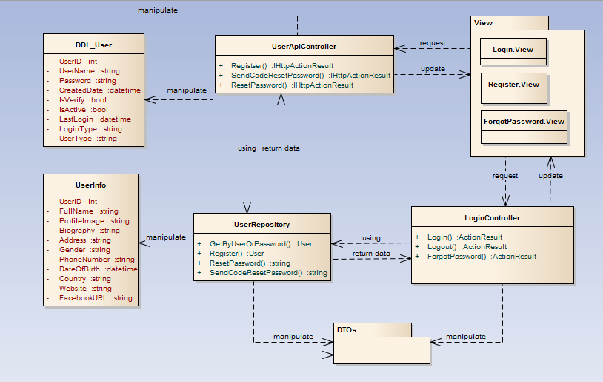

1. Common functions class diagram

### Sequence diagram

#### Login

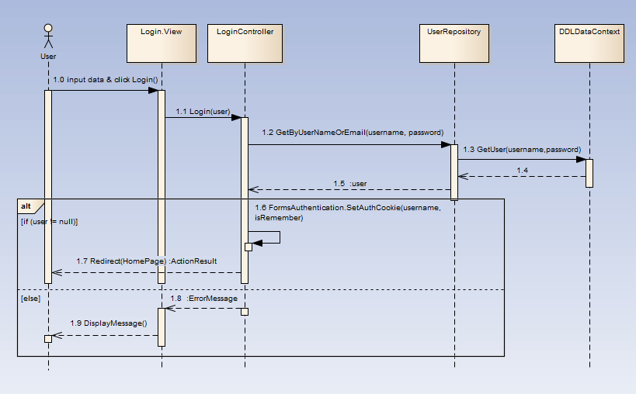

1. Login sequence diagram

#### Logout

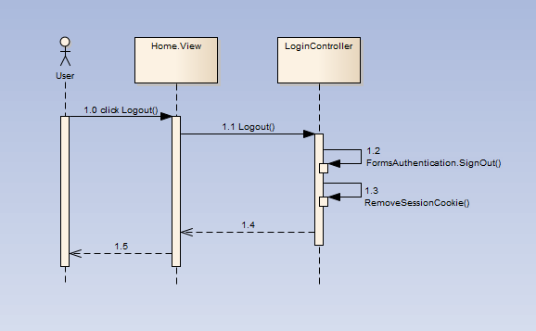

1. Logout sequence diagram

#### Register

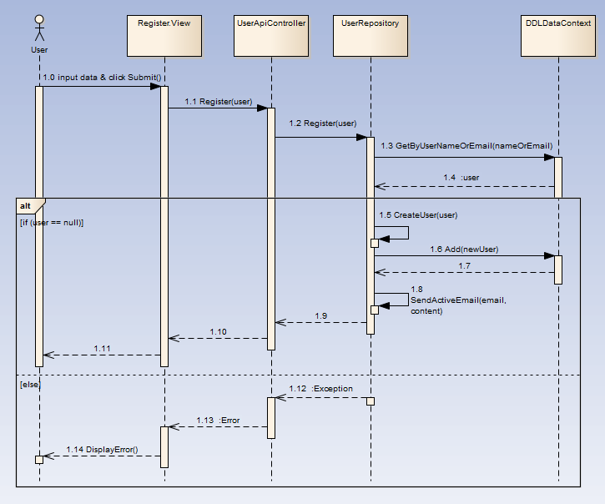

1. Register sequence diagram

#### Forgot Password

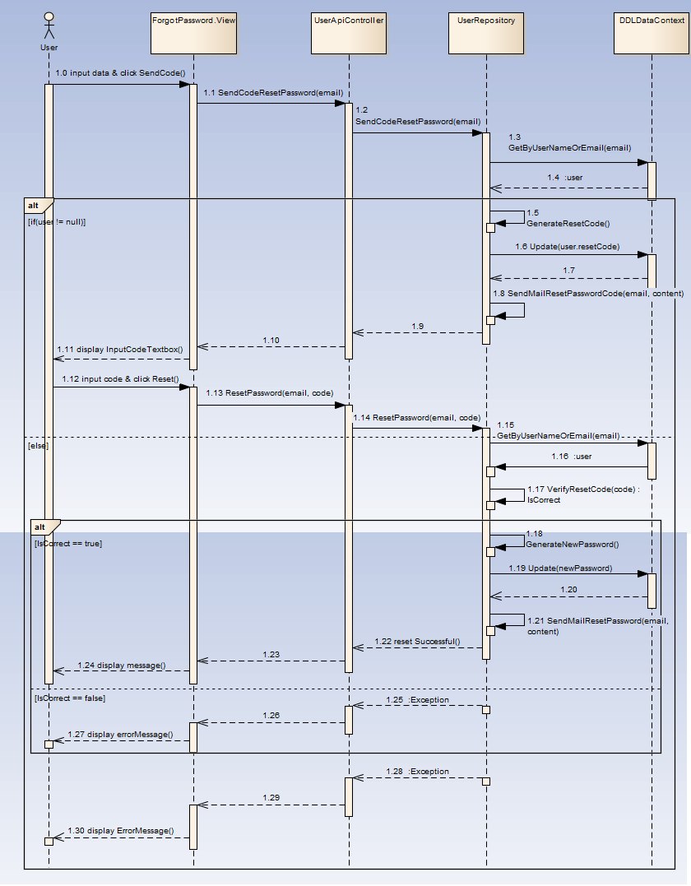

1. Forgot password sequence diagram

## Project

### Class diagram

### Sequence diagram

#### Create project

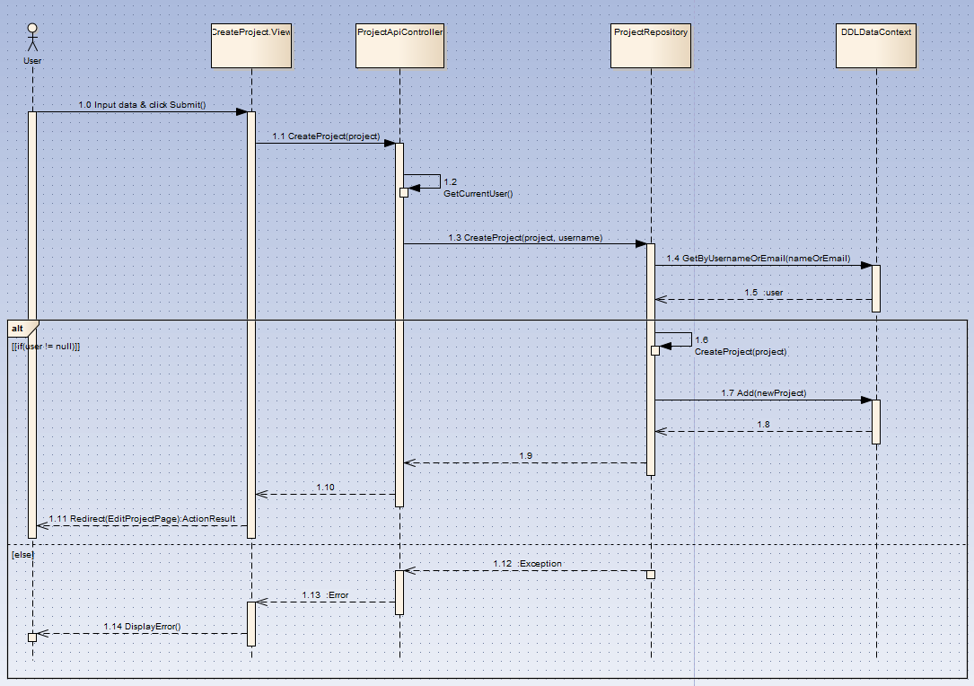

1. Create project sequence diagram

#### Edit project basic

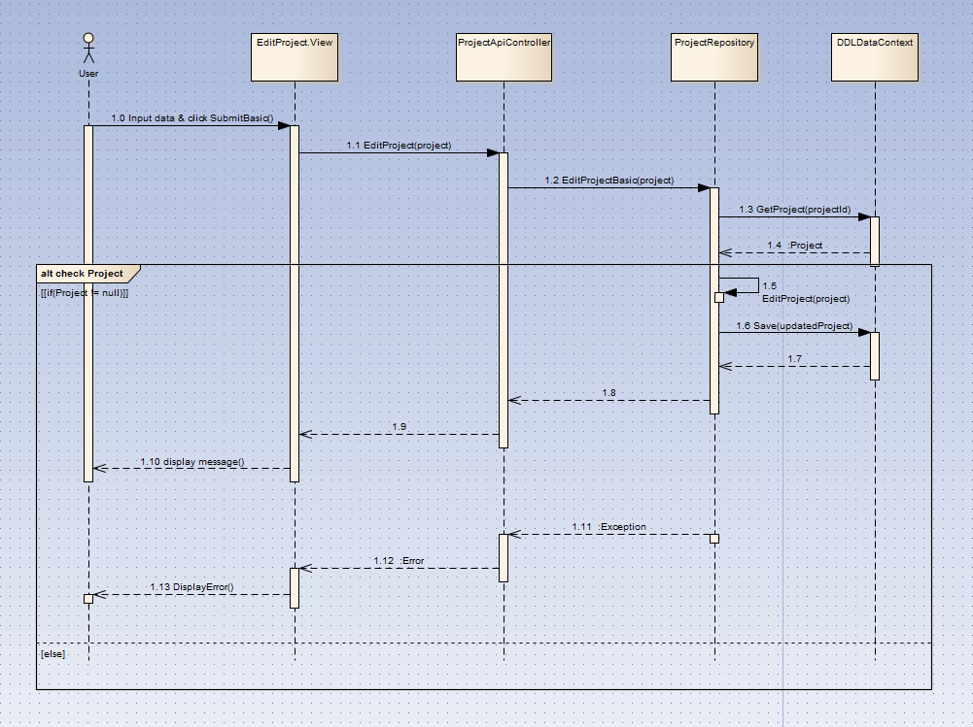

1. Edit project basic sequence diagram

#### Create reward packet

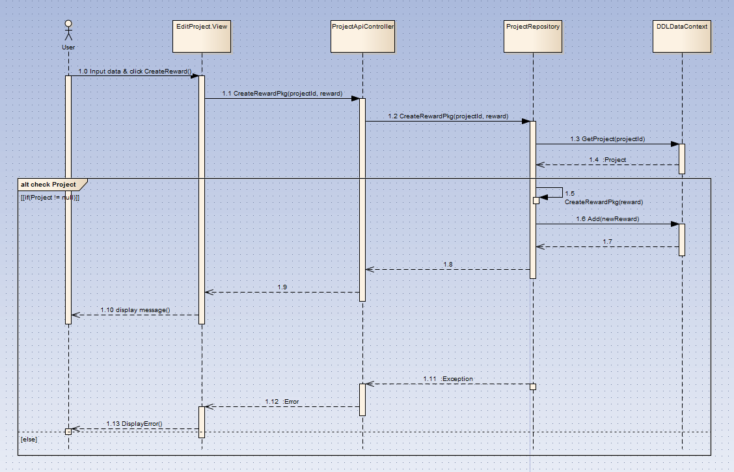

1. Create reward packet sequence diagram

#### Edit reward packet

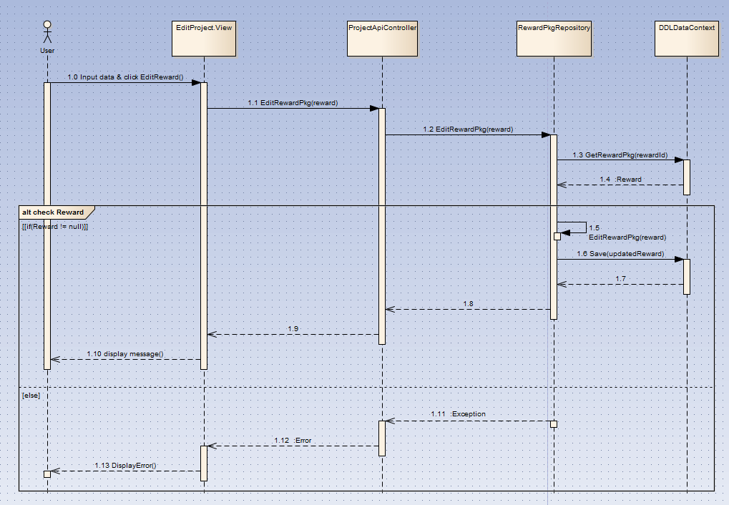

1. Edit reward packet sequence diagram

#### Delete reward packet

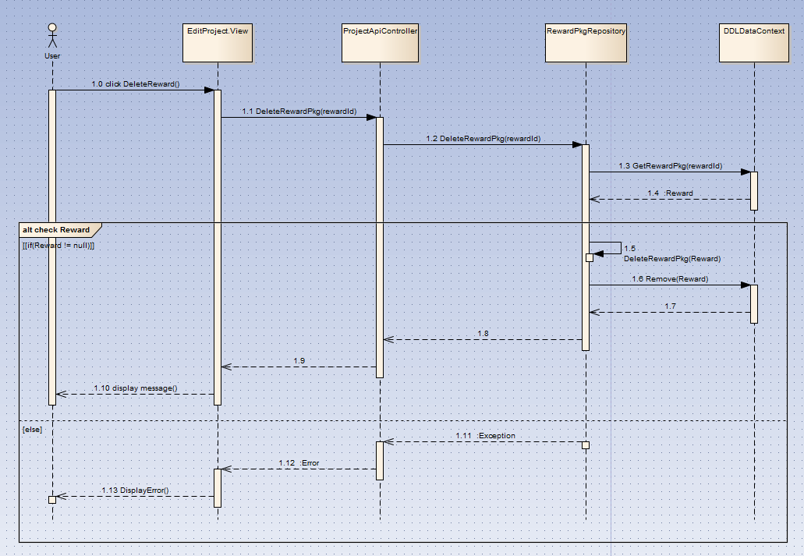

1. Delete reward packet sequence diagram

#### Edit project story

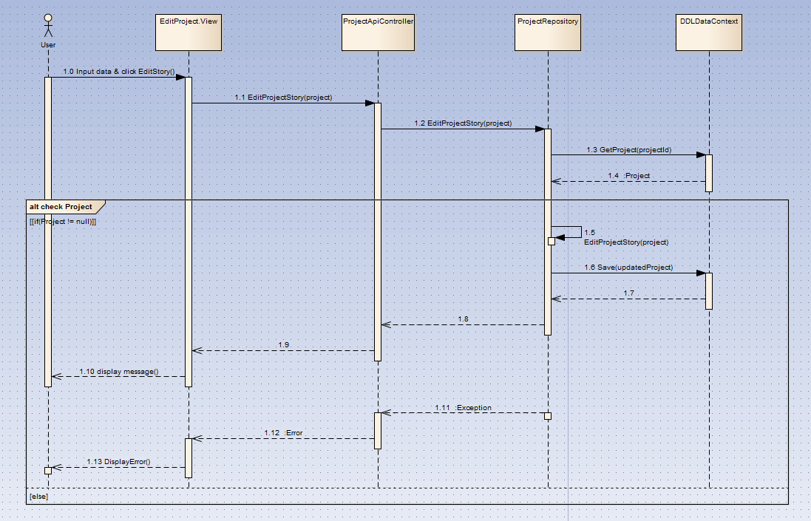

1. Edit project story sequence diagram

#### Create update log

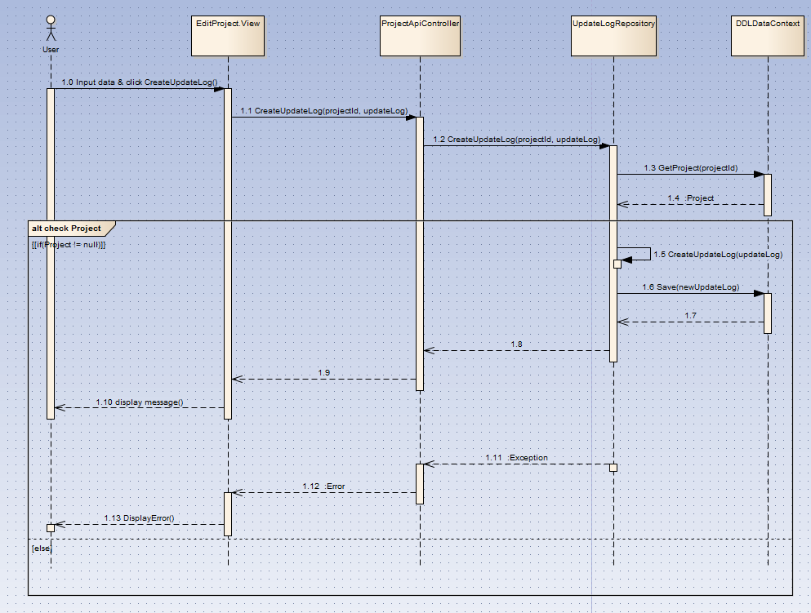

1. Create update log sequence diagram

#### Edit update log

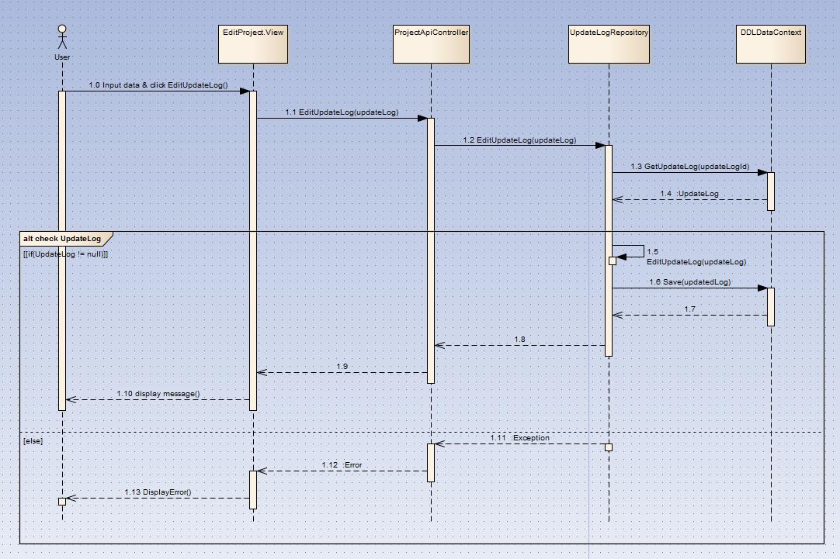

1. Edit update log sequence diagram

#### Delete update log

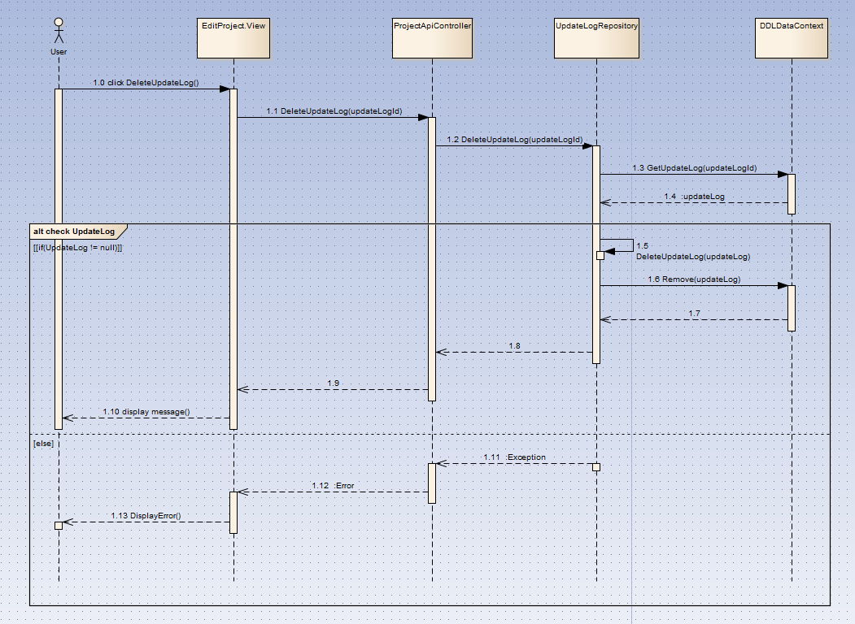

1. Delete update log sequence diagram

#### Create Q&A

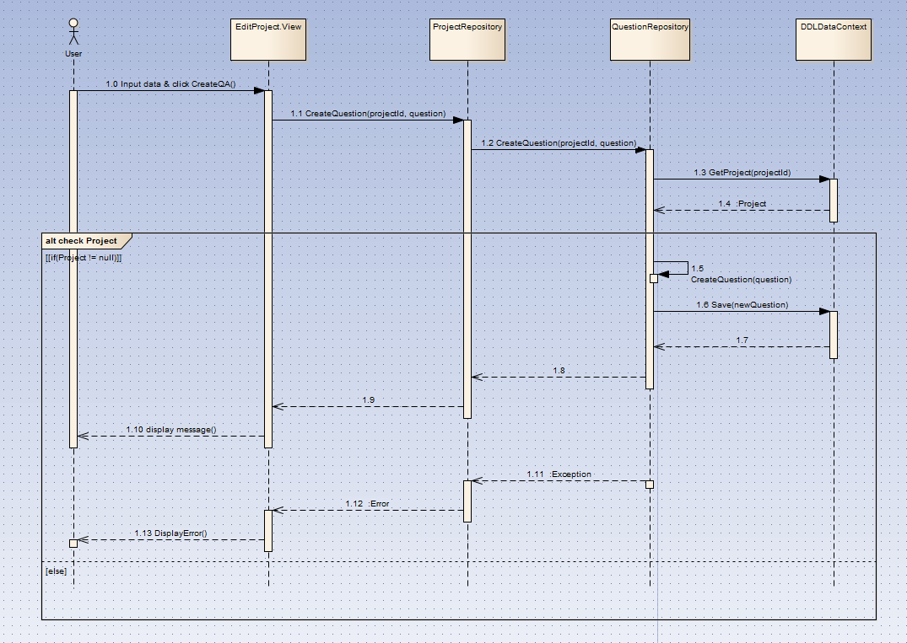

1. Create Q&A sequence diagram

#### Edit Q&A

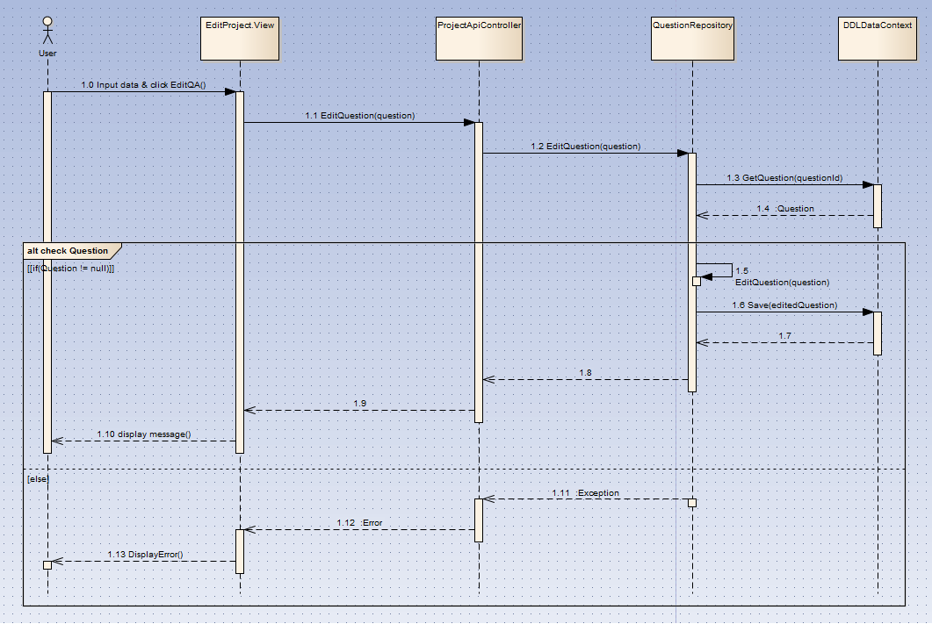

1. Edit Q&A sequence diagram

#### Delete Q&A

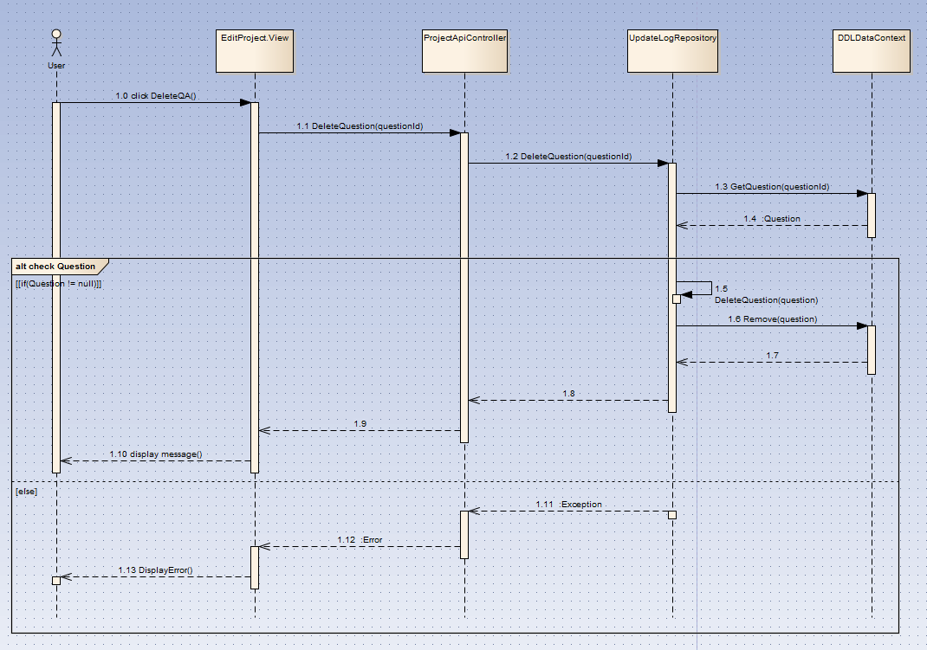

1. Delete Q&A sequence diagram

#### Delete project

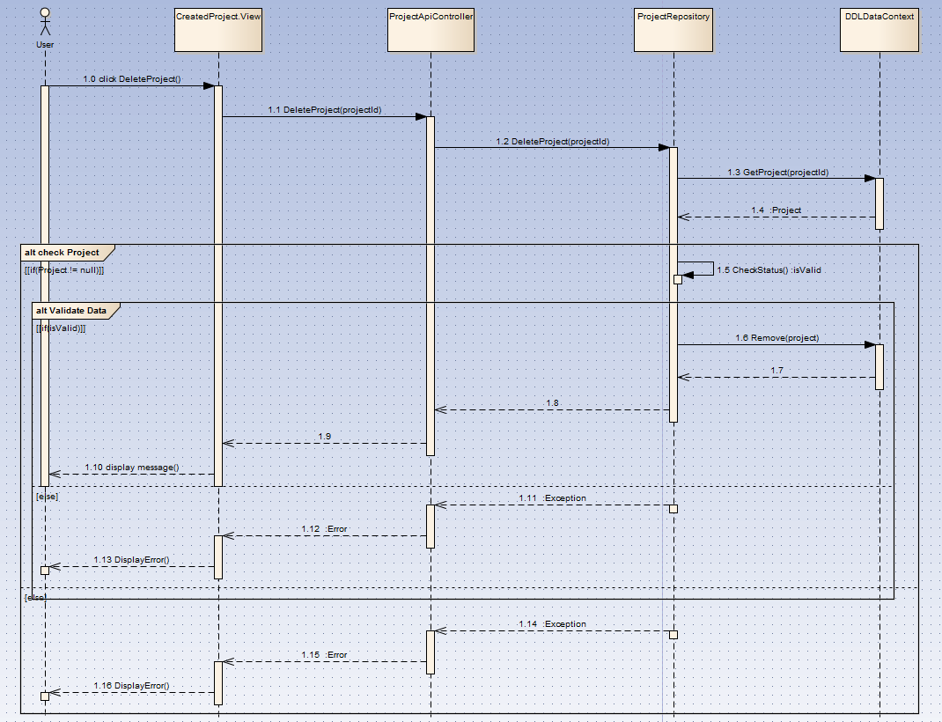

1. Delete project sequence diagram

#### Change project status

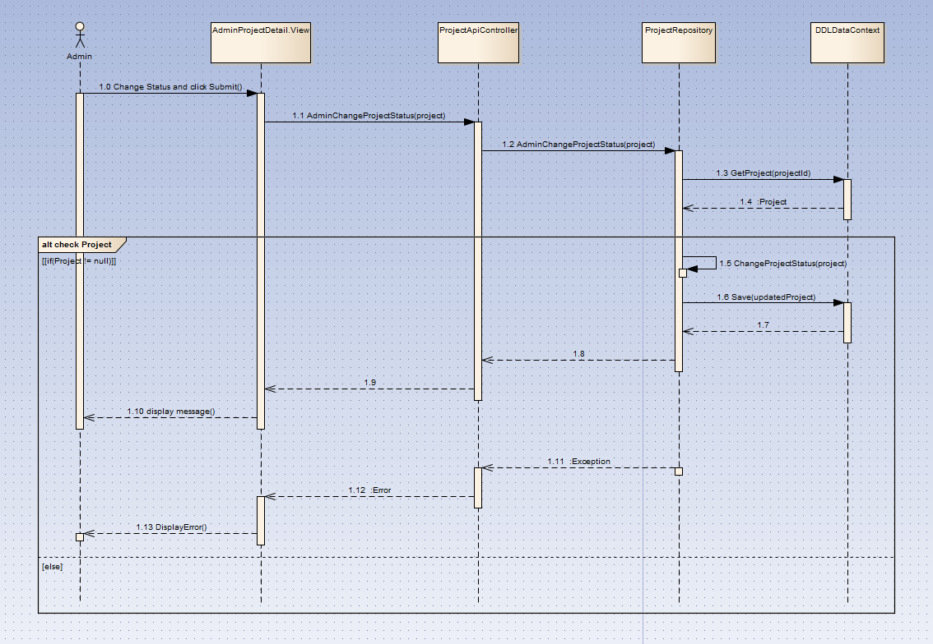

1. Change project status sequence diagram

#### Back project

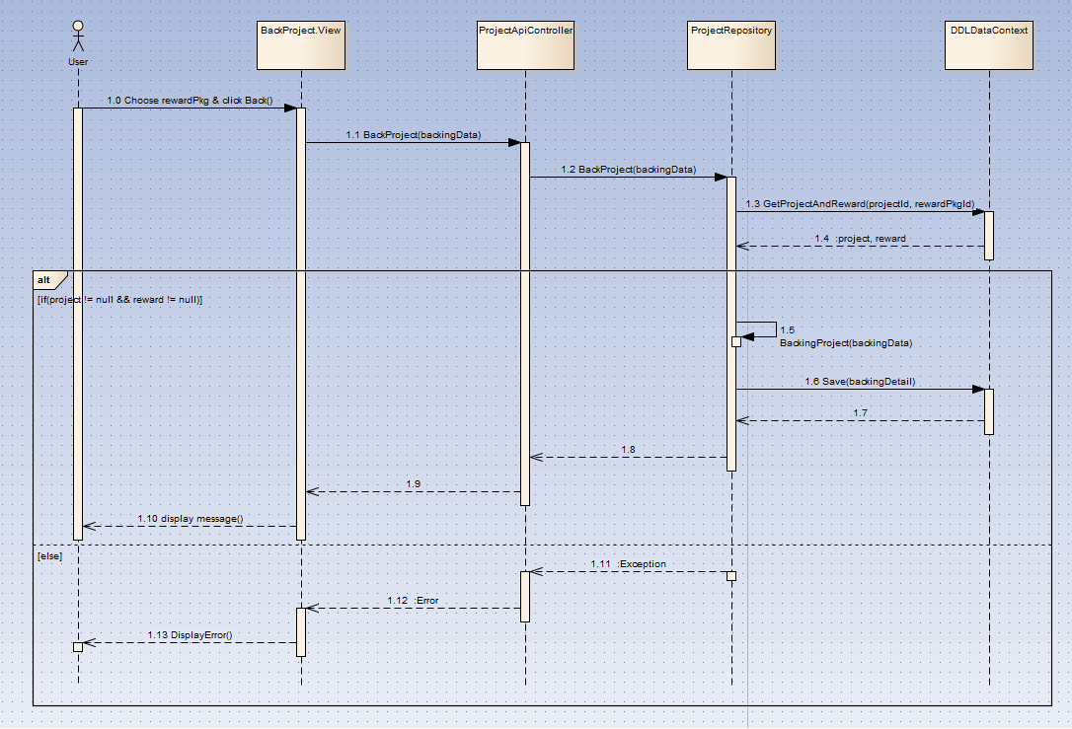

1. Back project sequence diagram

#### Submit project

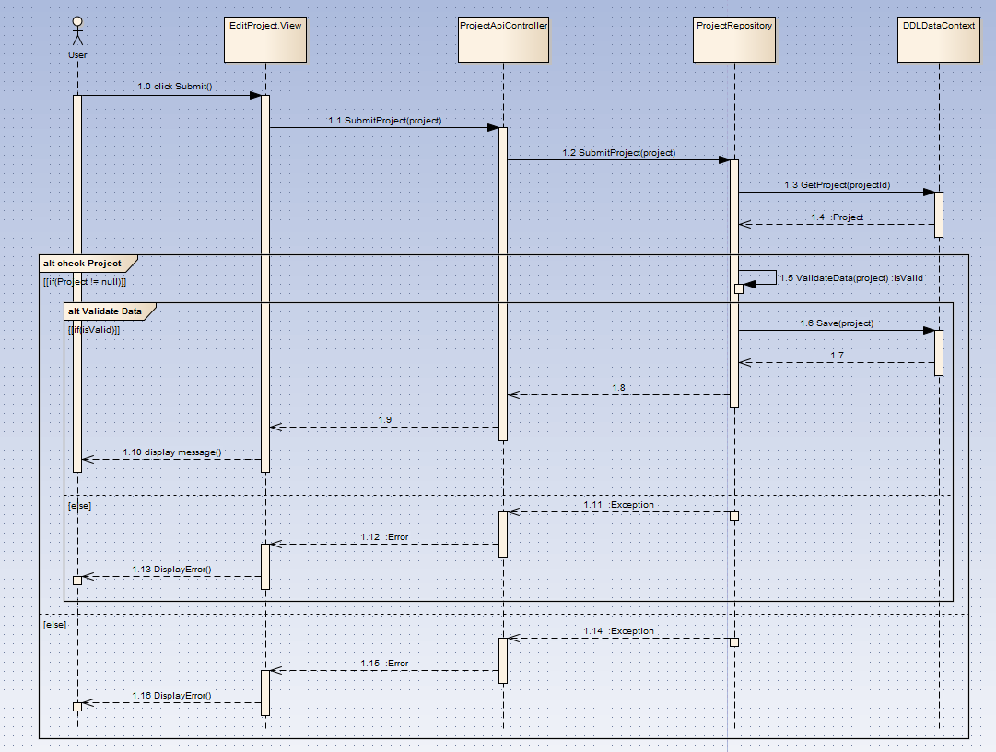

1. Submit project sequence diagram

#### Remind/ Unremind Project

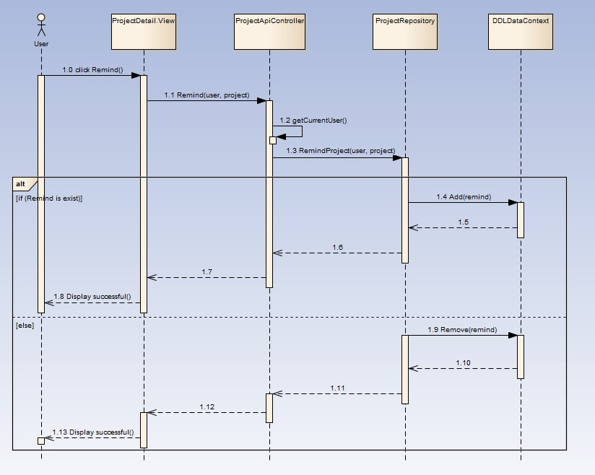

1. Remind/ Unremind project sequence diagram

#### Search

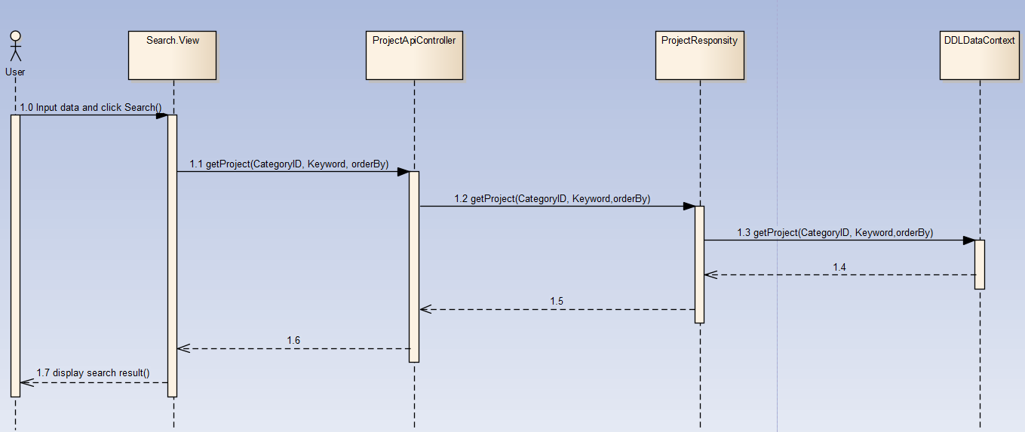

1. Search project sequence diagram

## Comment

### Class diagram

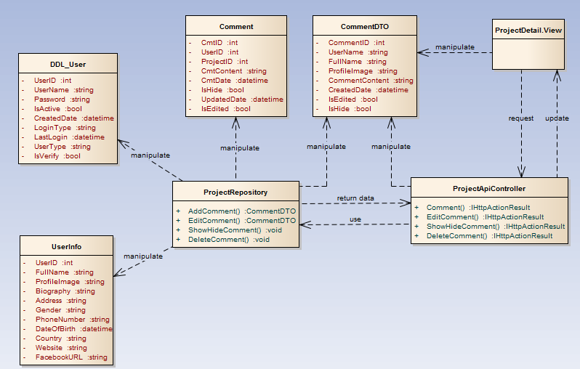

1. Comment function class diagram

### Sequence diagram

#### Add new comment

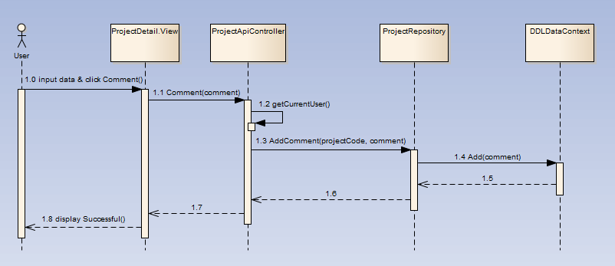

1. Add new comment sequence diagram

#### Edit comment

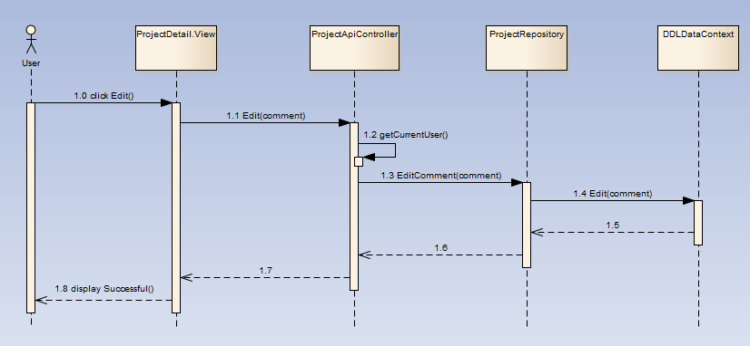

1. Edit comment sequence diagram

#### Show/hide comment

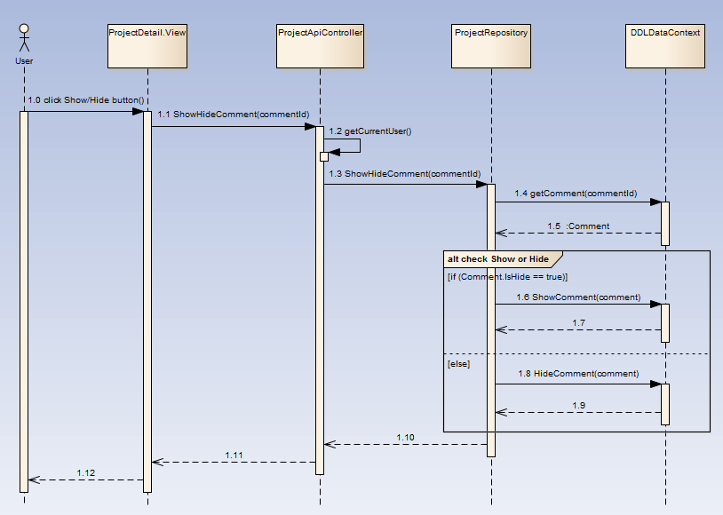

1. Show/hide comment sequence diagram

#### Delete comment

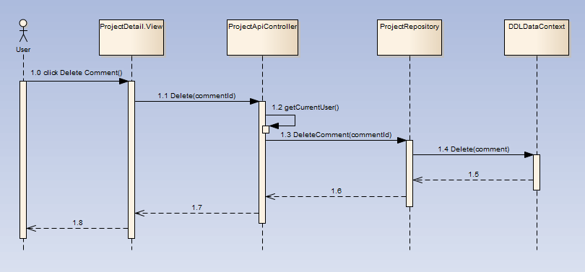

1. Delete comment sequence diagram

## Message

### Class diagram

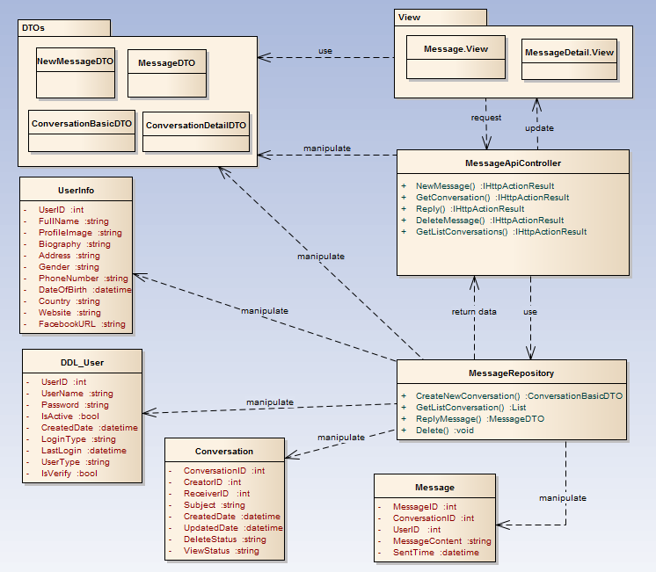

1. Message function class diagram

### Sequence diagram

#### Send message

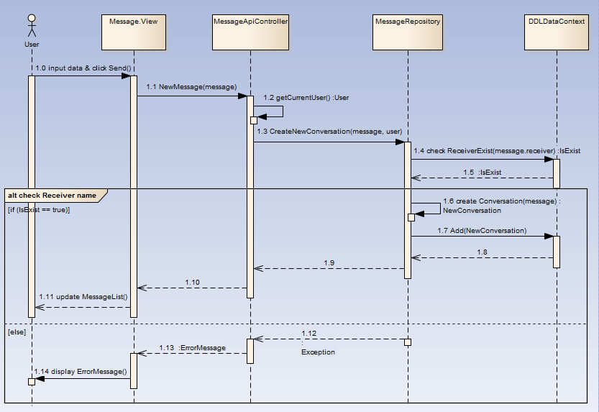

1. Send message sequence diagram

#### Delete message

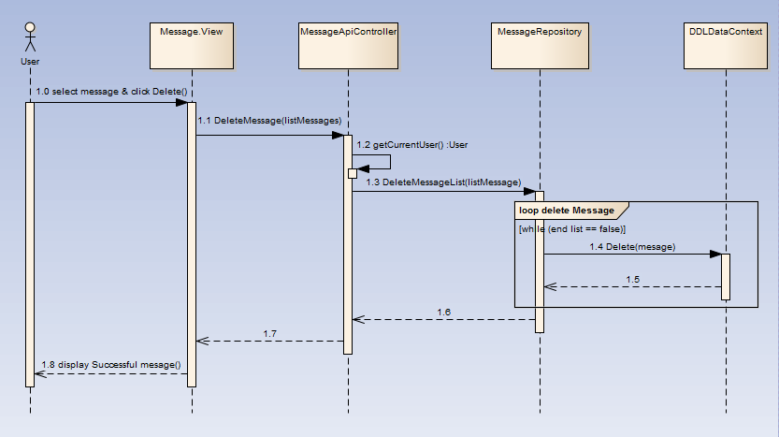

1. Delete message sequence diagram

#### Reply message

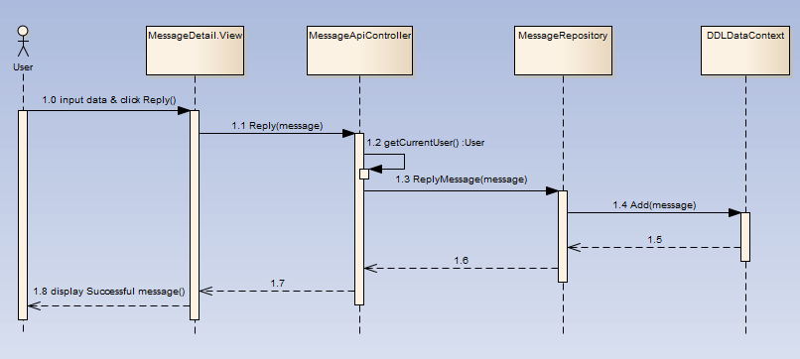

1. Reply message sequence diagram

## User

### Class diagram

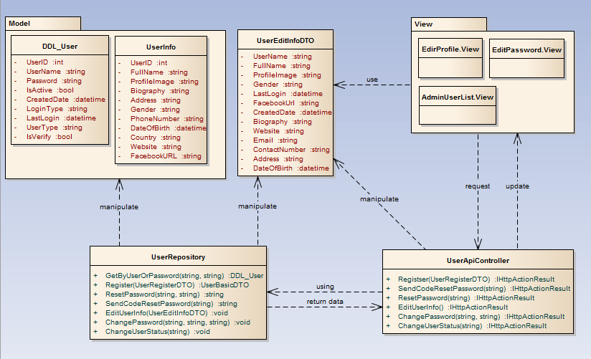

1. User functions class diagram

### Sequence diagram

#### Edit profile

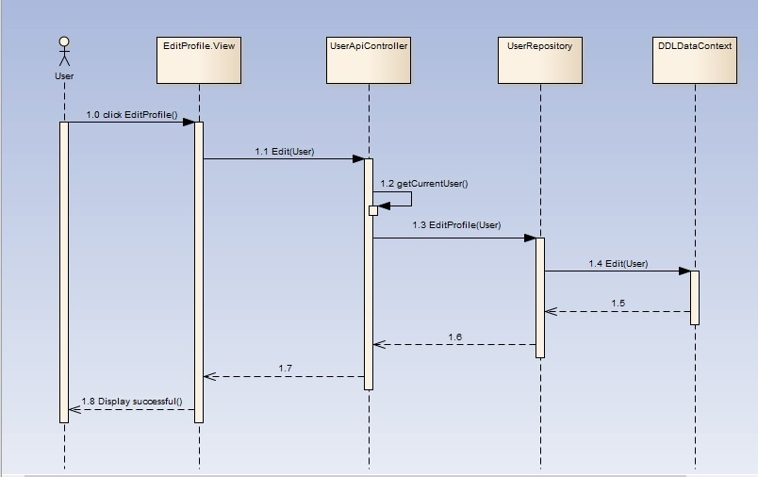

1. Edit profile sequence diagram

#### Change password

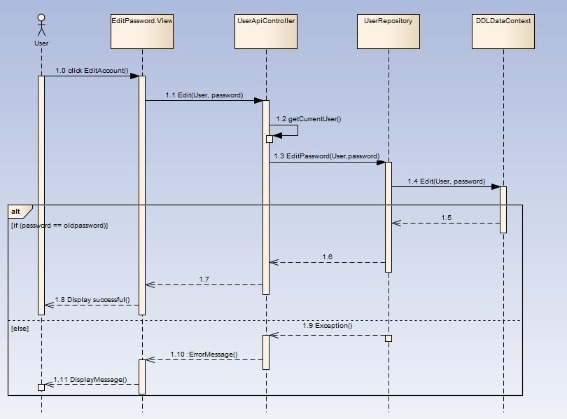

1. Change password sequence diagram

#### Active/deactive user

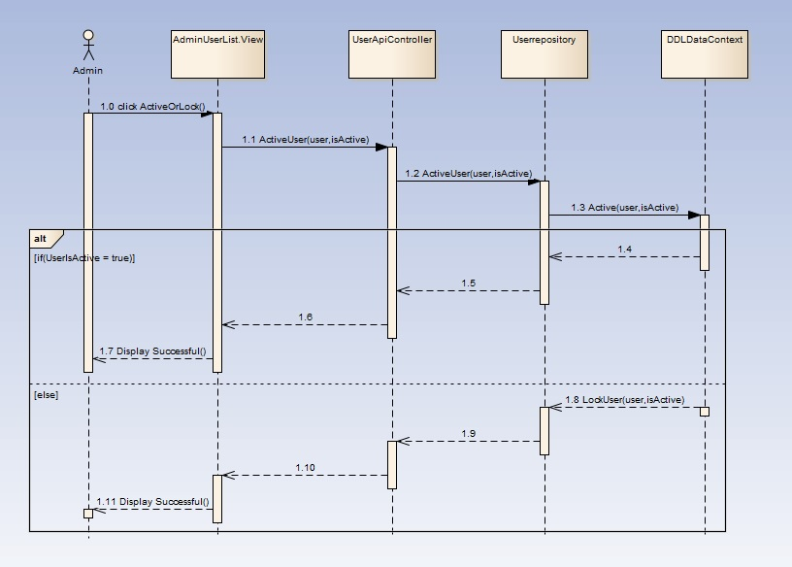

1. Active/ deactive user sequence diagram

## Report

### Class diagram

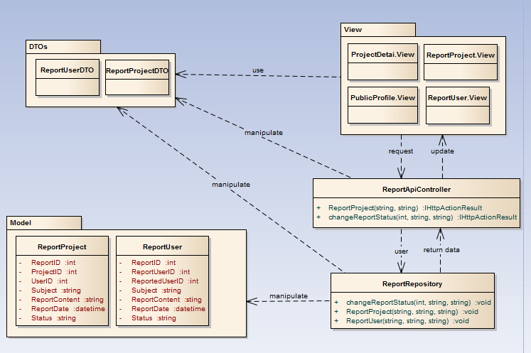

1. Report functions class diagram

### Sequence diagram

#### Report Project

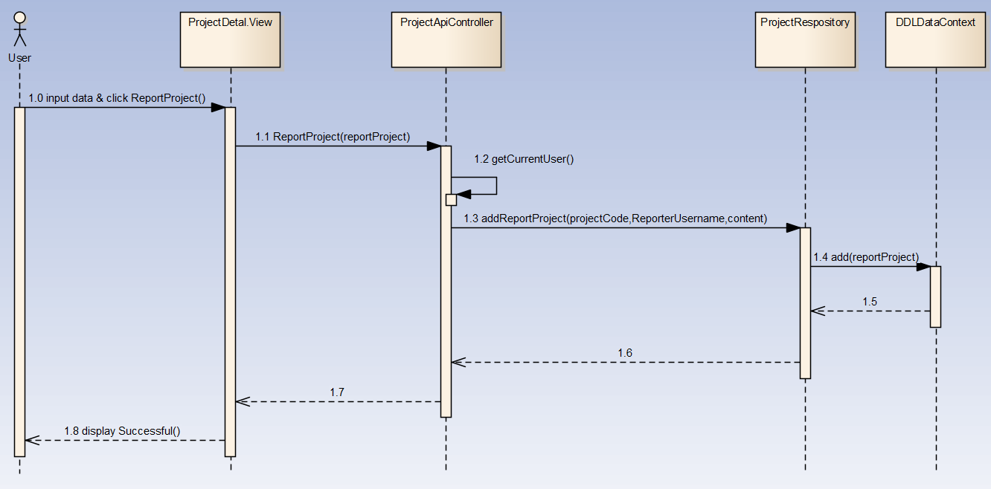

1. Report project sequence diagram

#### Report User

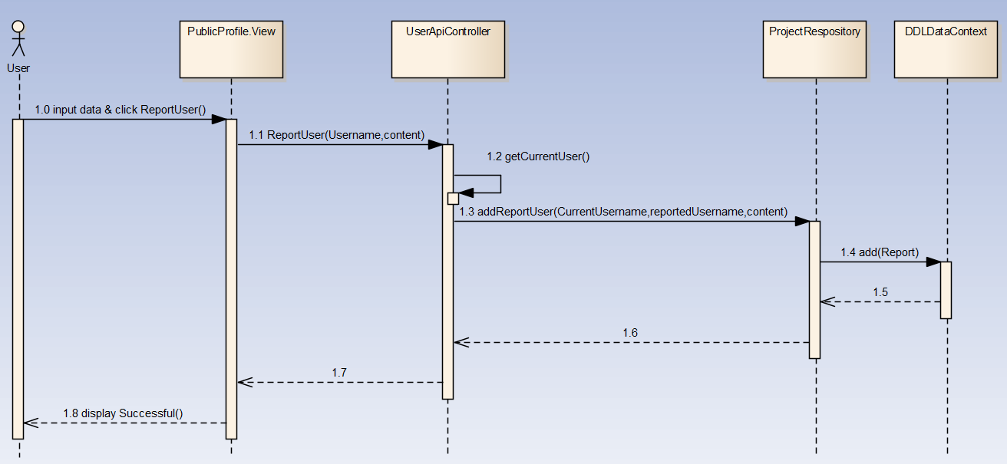

1. Report user sequence diagram

#### Change Report Project Status

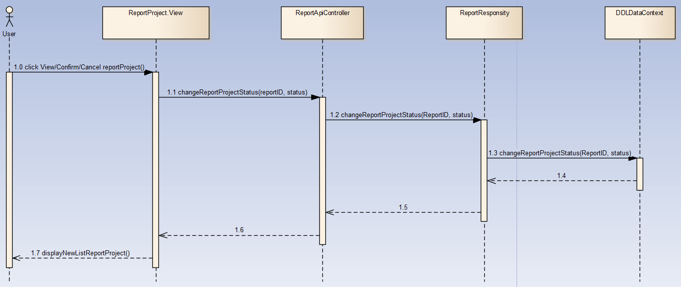

1. Change Report Project Status sequence diagram

#### Change Report User Status

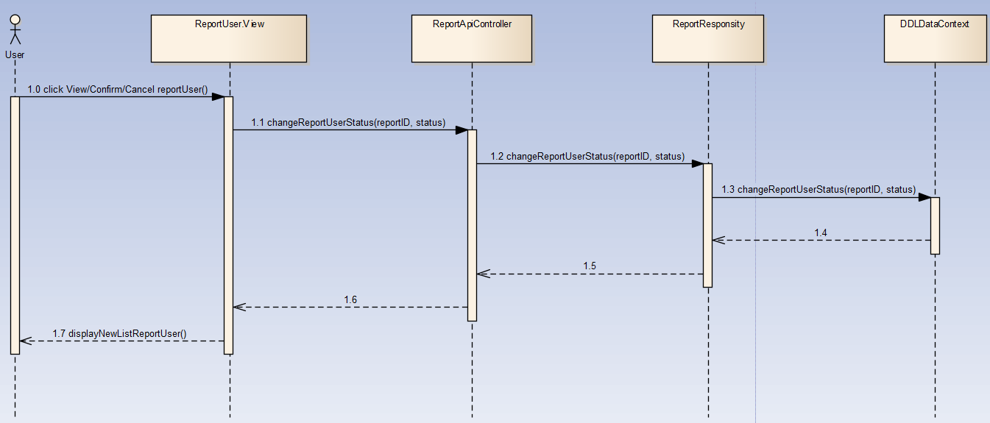

1. Change Report Project Status sequence diagram

## Manage Slide

### Class diagram

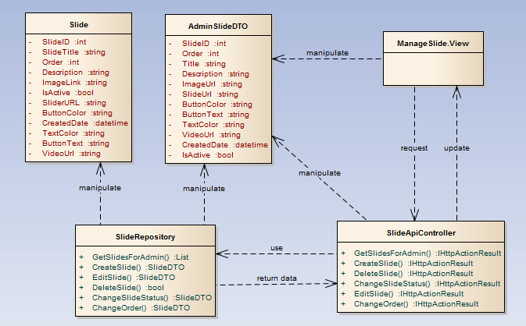

1. Manage Slide class diagram

### Sequence diagram

#### Add slide

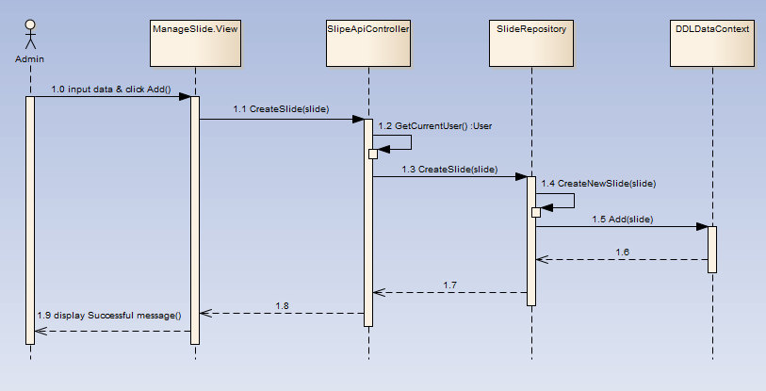

1. Add slide sequence diagram

#### Edit slide

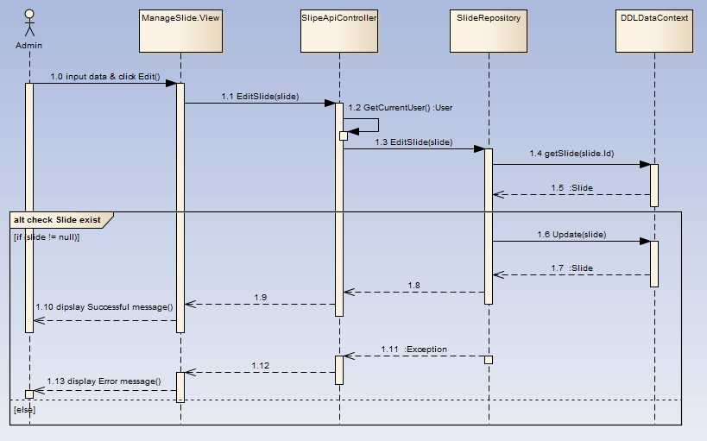

1. Edit slide sequence diagram

#### Delete slide

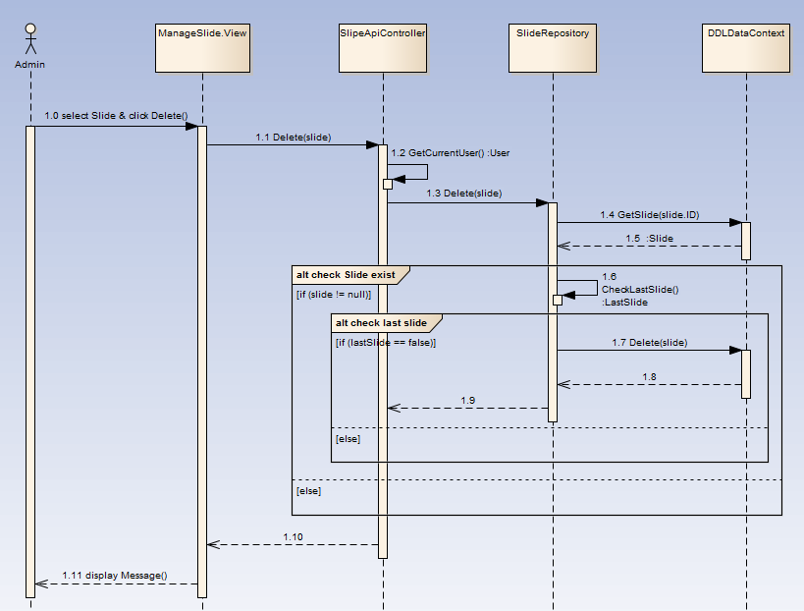

1. Delete slide sequence diagram

#### Active/deactive slide

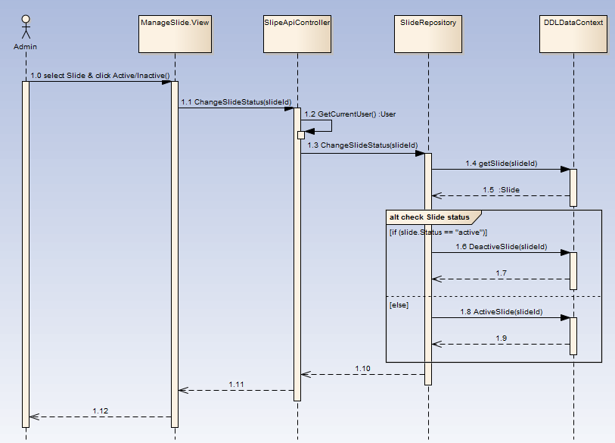

1. Active/deactive slide sequence diagram

#### Change slide order

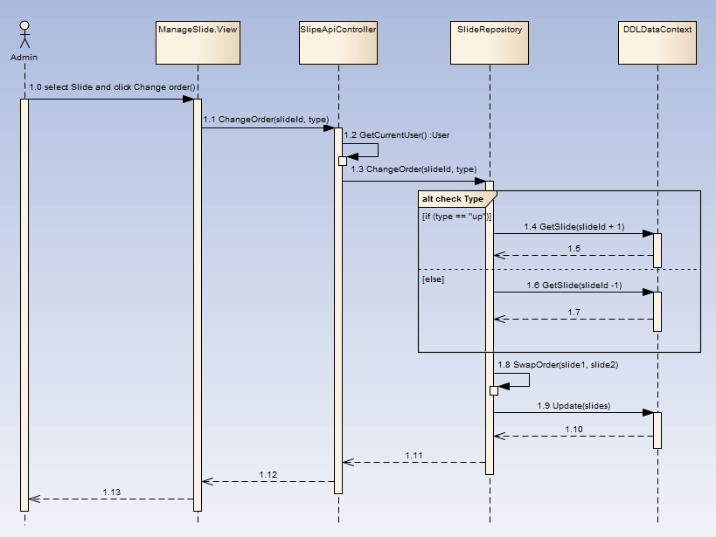

1. Change slide order sequence diagram

## Manage Category

### Class diagram

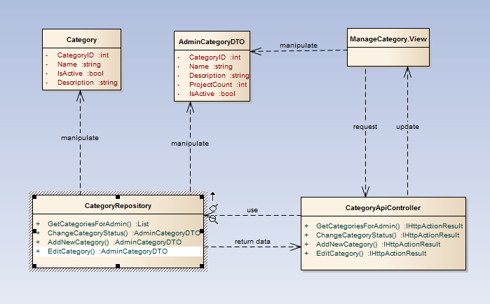

1. Manage category class diagram

### Sequence diagram

#### Add category

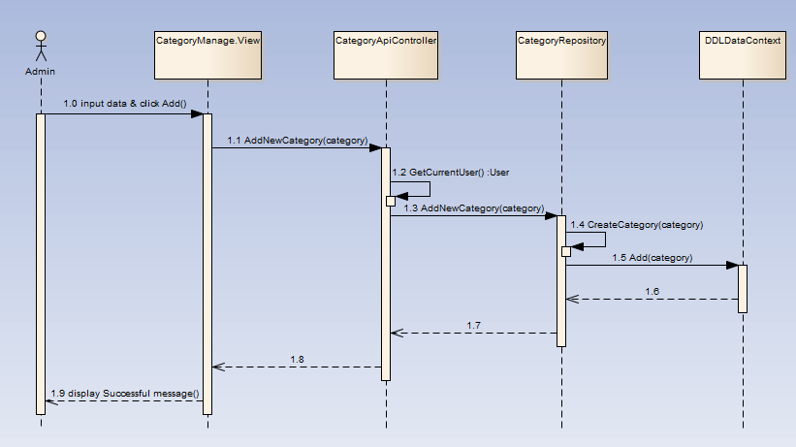

1. Add category sequence diagram

#### Edit category

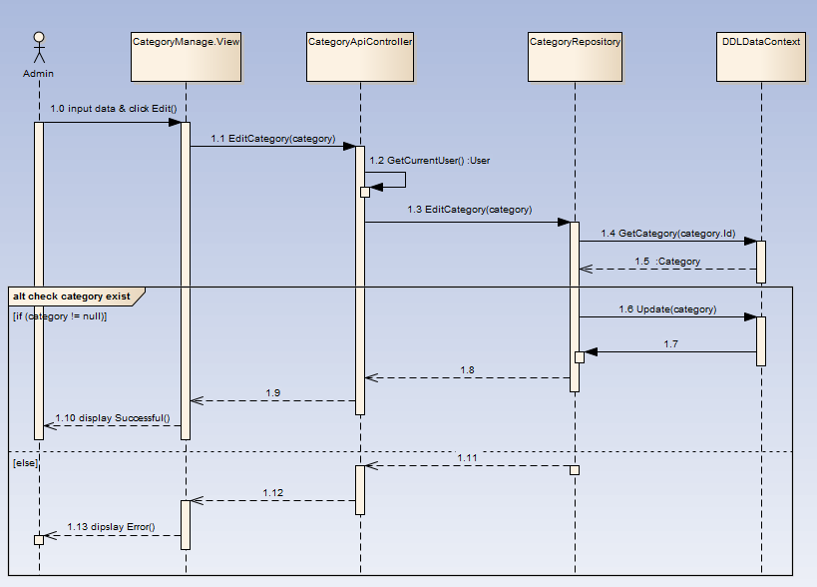

1. Edit category sequence diagram

#### Active/deactive category

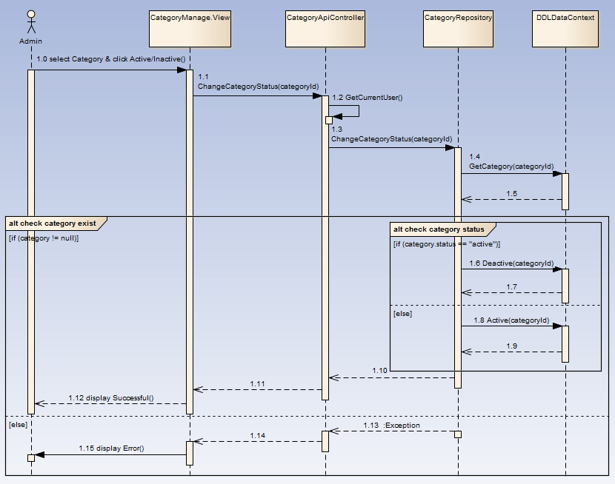

1. Active/deactive category sequence diagram